PRACTICAL :-1

AIM: Implementation of Perceptron Learning Algorithm for Admission Prediction.

Problem Statement:-

Design and implement a single-layer Perceptron Neural Network to classify student admission eligibility using entrance examination marks and interview scores. Train the model on linearly separable data, predict admission outcomes for new applicants, visualize the decision boundary, and evaluate the impact of learning rate and epochs on the training process.

Source Code:-

import numpy as np
import matplotlib.pyplot as plt

# Admission Dataset X = np.array([
[35, 40],
[40, 45],
[45, 48],
[50, 52],
[55, 58],
[70, 72],
[75, 80],
[82, 85],
[90, 92]
], dtype=float)

# Feature Scaling X = X / 100

y = np.array([0, 0, 0, 0, 0, 1, 1, 1, 1])

# Perceptron Class class Perceptron:

def init(self, learning_rate=0.1, epochs=50): self.lr = learning_rate
self.epochs = epochs

def train(self, X, y):
self.weights = np.zeros(X.shape[1])

self.bias = 0 self.errors = []

for epoch in range(self.epochs): error_count = 0

for xi, target in zip(X, y):
activation = np.dot(xi, self.weights) + self.bias prediction = 1 if activation >= 0 else 0

error = target - prediction

self.weights += self.lr * error * xi self.bias += self.lr * error

if error != 0: error_count += 1

self.errors.append(error_count)
print(f"Epoch {epoch+1:2d} Errors = {error_count}")

if error_count == 0: print("\nTraining Converged.") break

def predict(self, X):
activation = np.dot(X, self.weights) + self.bias return np.where(activation >= 0, 1, 0)

# Create Model model = Perceptron() model.train(X, y)

# Accuracy
pred = model.predict(X)
accuracy = np.mean(pred == y) * 100 print("\nAccuracy =", accuracy, "%")

# Test New Student print("\nAdmission Prediction")

entrance = float(input("Entrance Marks : ")) / 100 interview = float(input("Interview Score : ")) / 100

new = np.array([[entrance, interview]]) result = model.predict(new)
if result[0] == 1:
print("\nEligible for Admission") else:
print("\nNot Eligible for Admission")

# Plot Dataset plt.figure(figsize=(7, 6))

for i in range(len(X)): if y[i] == 0:
plt.scatter( X[i, 0],
X[i, 1],
color="red",
label="Not Admitted" if i == 0 else ""
)
else:
plt.scatter( X[i, 0],
X[i, 1],
color="blue",
label="Admitted" if i == 5 else ""
)

x = np.linspace(0.3, 1, 100)
y_line = -(model.weights[0] * x + model.bias) / model.weights[1]

plt.plot(x, y_line, color="green", label="Decision Boundary")

plt.xlabel("Entrance Marks (Normalized)") plt.ylabel("Interview Score (Normalized)") plt.title("Admission Prediction using Perceptron")

plt.legend() plt.grid(True) plt.show()

# Learning Curve plt.figure(figsize=(6, 4))

plt.plot(
range(1, len(model.errors) + 1), model.errors,
marker="o"
)

plt.xlabel("Epoch") plt.ylabel("Classification Errors") plt.title("Learning Curve")

plt.grid(True) plt.show()

OUTPUT:-
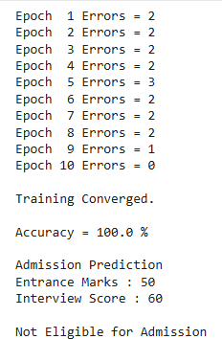

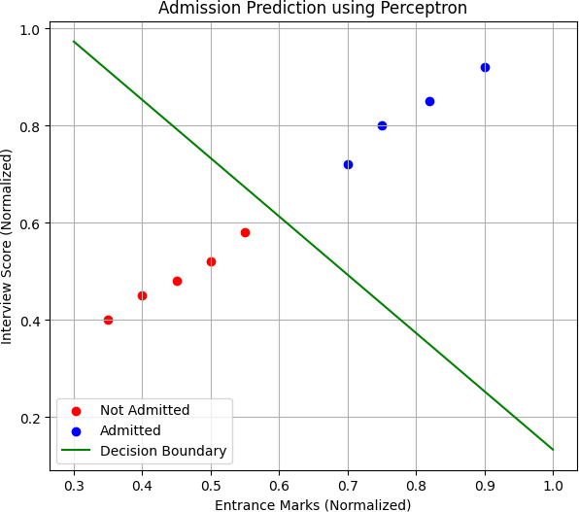

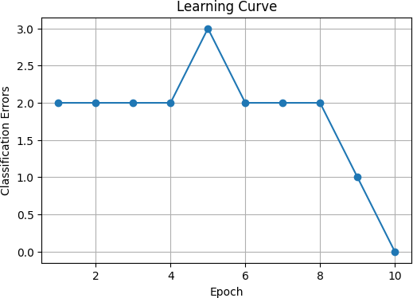

Assignment:01:-

Implementation of Perceptron Learning Algorithm for Student Placement Prediction .

Problem Statement :-

Develop a single-layer Perceptron Neural Network to predict whether a student is likely to be Placed or Not Placed based on academic performance indicators such as CGPA and coding assessment score. Train the model using supervised learning, classify new student records, visualize the decision boundary, and analyze the effect of learning rate and epochs on model convergence and classification accuracy.

CODE:-

import numpy as np
import matplotlib.pyplot as plt

#
# Dataset
# CGPA , Coding Score #
X = np.array([ [5.5, 40],
[6.0, 45],
[6.2, 50],
[6.5, 55],
[6.8, 58],
[7.2, 65],
[7.5, 70],
[8.0, 75],
[8.3, 80],
[8.5, 85],
[8.8, 90],
[9.2, 95]
], dtype=float)

# Output
# 0 = Not Placed # 1 = Placed
y = np.array([0,0,0,0,0,1,1,1,1,1,1,1]) #
# Feature Scaling

#
X[:,0] = X[:,0] / 10
X[:,1] = X[:,1] / 100

#
# Perceptron Class #

class Perceptron:

def init(self, learning_rate=0.1, epochs=50): self.lr = learning_rate
self.epochs = epochs def train(self, X, y):
self.weights = np.zeros(X.shape[1]) self.bias = 0
self.errors = []

for epoch in range(self.epochs): error_count = 0
for xi, target in zip(X, y):

activation = np.dot(xi, self.weights) + self.bias prediction = 1 if activation >= 0 else 0
error = target - prediction

self.weights += self.lr * error * xi self.bias += self.lr * error

if error != 0: error_count += 1

self.errors.append(error_count)
print("Epoch", epoch+1, "Errors =", error_count) if error_count == 0:
print("\nTraining Converged")

break

def predict(self, X):

activation = np.dot(X, self.weights) + self.bias return np.where(activation >= 0, 1, 0)

#
# Train Model #

model = Perceptron(learning_rate=0.1, epochs=50) model.train(X, y)
#
# Accuracy #

prediction = model.predict(X)

accuracy = np.mean(prediction == y) * 100 print("\nAccuracy =", accuracy,"%")
#
# Test New Student #

print("\nPlacement Prediction")

cgpa = float(input("Enter CGPA (Out of 10): "))
coding = float(input("Enter Coding Score (Out of 100): ")) new_student = np.array([[cgpa/10, coding/100]])
result = model.predict(new_student)

if result[0] == 1:
print("\nStudent is Likely to be PLACED") else:
print("\nStudent is NOT LIKELY to be PLACED")

#
# Plot Dataset #

plt.figure(figsize=(7,6)) for i in range(len(X)):
if y[i] == 0: plt.scatter(
X[i,0],
X[i,1],
color='red', s=100,
label='Not Placed' if i==0 else ""
)

else:
plt.scatter( X[i,0],
X[i,1],
color='blue', s=100,
label='Placed' if i==5 else ""
)

x = np.linspace(0.4,1.0,100)

y_line = -(model.weights[0]*x + model.bias)/model.weights[1]
plt.plot(x, y_line, color='green', linewidth=2, label='Decision Boundary') plt.xlabel("CGPA (Normalized)")
plt.ylabel("Coding Score (Normalized)")
plt.title("Student Placement Prediction using Perceptron") plt.legend()
plt.grid(True) plt.show()

#
# Learning Curve #

plt.figure(figsize=(6,4))

plt.plot(
range(1, len(model.errors)+1), model.errors,
marker='o', color='purple'
)

plt.xlabel("Epoch") plt.ylabel("Classification Errors") plt.title("Learning Curve") plt.grid(True)
plt.show()

OUTPUT:-
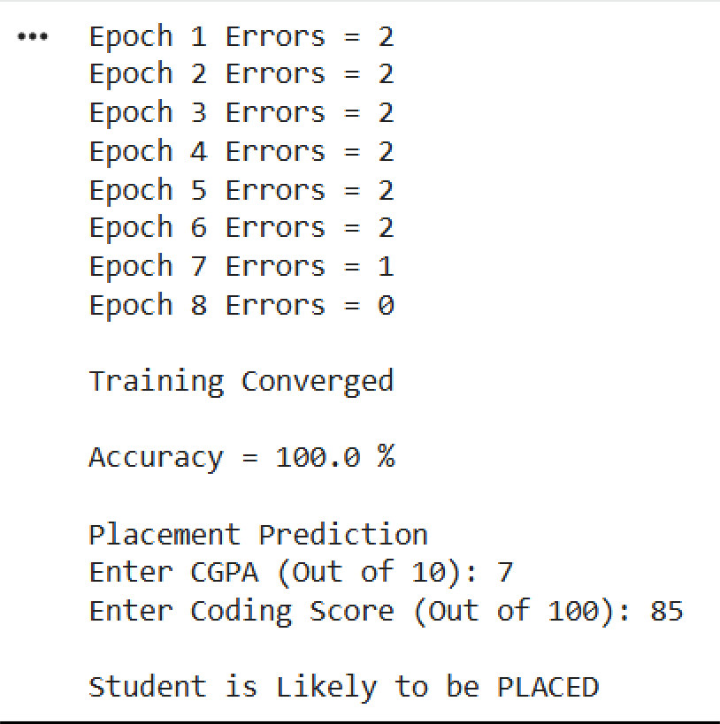

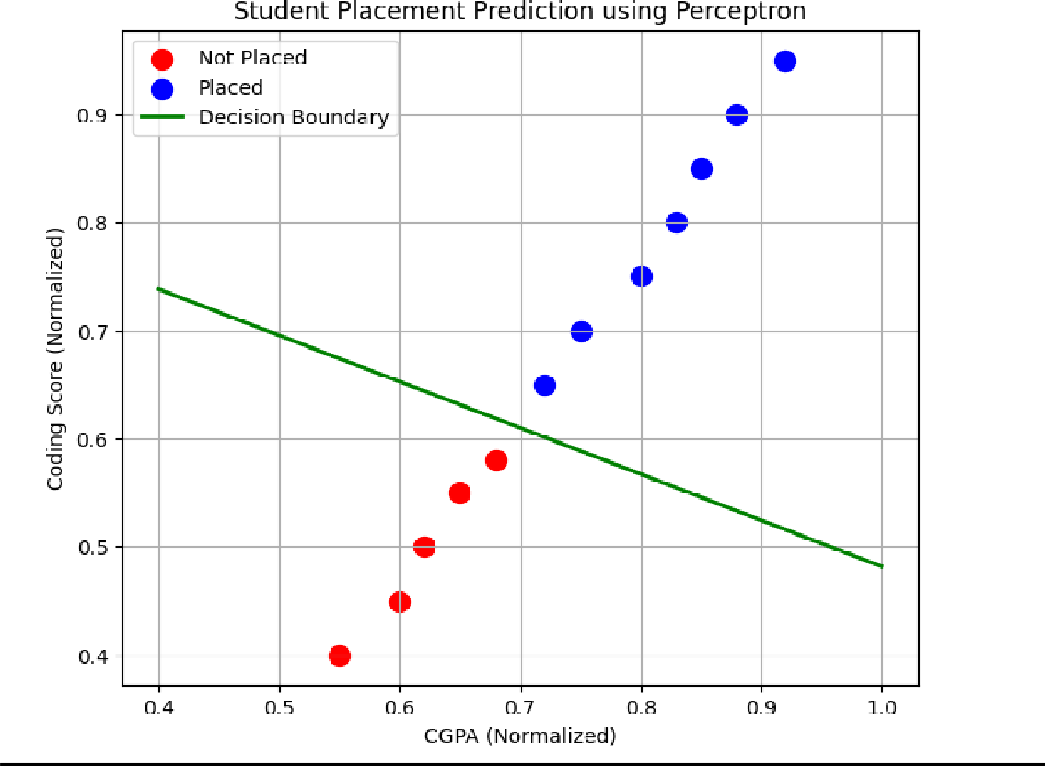

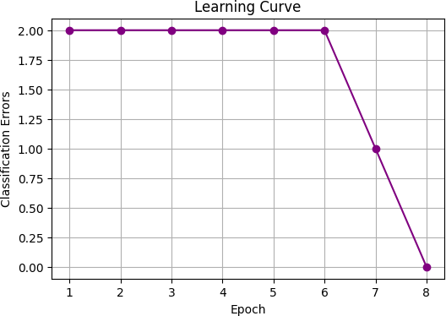

Assignment:02:-

Loan Approval Prediction using Perceptron Learning Algorithm

Problem Statement:-

Develop a single-layer Perceptron Neural Network to classify loan applications as Approved or Rejected based on applicant attributes such as annual income and credit score. Train the model using labeled data, visualize the decision boundary, and investigate the effect of learning rate and epochs on classification performance.

CODE:-

import numpy as np import pandas as pd
import matplotlib.pyplot as plt

data = {
"Annual_Income": [
25000, 30000, 35000, 40000, 42000,
45000, 48000, 50000, 52000, 55000,
58000, 60000, 62000, 65000, 68000,
70000, 75000, 80000, 85000, 90000
],
"Credit_Score": [
550, 580, 600, 610, 620,
630, 640, 650, 660, 670,
680, 690, 700, 710, 720,
730, 740, 750, 760, 780
],
"Loan_Status": [ 0, 0, 0, 0, 0,
0, 0, 1, 1, 1,
1, 1, 1, 1, 1,
1, 1, 1, 1, 1
]
}

df = pd.DataFrame(data)

print("=" * 60)
print("LOAN APPROVAL DATASET")
print("=" * 60) print(df.to_string(index=False))

X = df[["Annual_Income", "Credit_Score"]].values y = df["Loan_Status"].values

X_mean = X.mean(axis=0) X_std = X.std(axis=0)
X_scaled = (X - X_mean) / X_std

class Perceptron:

def init(self, learning_rate=0.01, epochs=100): self.learning_rate = learning_rate
self.epochs = epochs self.weights = None self.bias = 0 self.errors = []

def activation(self, value): if value >= 0:
return 1 else:
return 0

def predict(self, X):
linear_output = np.dot(X, self.weights) + self.bias return np.array([
self.activation(value)
for value in linear_output
])

def fit(self, X, y):
self.weights = np.zeros(X.shape[1]) self.bias = 0

self.errors = []

for epoch in range(self.epochs): total_errors = 0

for xi, target in zip(X, y): prediction = self.activation(
np.dot(xi, self.weights) + self.bias
)
update = self.learning_rate * (target - prediction) self.weights += update * xi
self.bias += update

if update != 0: total_errors += 1

self.errors.append(total_errors)

if total_errors == 0: break

return self

learning_rate = 0.01
epochs = 100

model = Perceptron( learning_rate=learning_rate, epochs=epochs
)

model.fit(X_scaled, y)

predictions = model.predict(X_scaled)

df["Predicted_Status"] = predictions

df["Prediction_Result"] = np.where( predictions == df["Loan_Status"], "Correct",
"Incorrect"
)
accuracy = np.mean(predictions == y) * 100 print("\n" + "=" * 60)
print("MODEL RESULTS")
print("=" * 60)

print("Learning Rate :", learning_rate) print("Maximum Epochs:", epochs) print("Actual Epochs :", len(model.errors))

print("\nFinal Weights:") print(model.weights)

print("\nBias:") print(model.bias)
print("\nAccuracy: {:.2f}%".format(accuracy)) print("\n" + "=" * 60)
print("PREDICTIONS")
print("=" * 60)

print(
df[
[
"Annual_Income", "Credit_Score", "Loan_Status", "Predicted_Status", "Prediction_Result"

]
].to_string(index=False)
)
plt.figure(figsize=(8, 5)) plt.plot(
range(1, len(model.errors) + 1), model.errors,
marker="o", color="blue"
)

plt.xlabel("Epoch")
plt.ylabel("Number of Misclassifications") plt.title("Perceptron Training Error") plt.grid(True)
plt.show()
plt.figure(figsize=(10, 6)) plt.scatter(
X_scaled[y == 0, 0],
X_scaled[y == 0, 1], color="red", marker="x",
s=100,
label="Rejected"
)

plt.scatter(
X_scaled[y == 1, 0],
X_scaled[y == 1, 1], color="green", marker="o",
s=100,
label="Approved"
)

x_min = X_scaled[:, 0].min() - 0.5 x_max = X_scaled[:, 0].max() + 0.5
x_values = np.linspace(x_min, x_max, 100) if model.weights[1] != 0:
y_values = (
-(model.weights[0] * x_values + model.bias)
/ model.weights[1]
)

plt.plot(
x_values, y_values, color="black", linewidth=2,
label="Decision Boundary"
)

plt.xlabel("Annual Income (Scaled)") plt.ylabel("Credit Score (Scaled)")
plt.title("Loan Approval - Perceptron Decision Boundary") plt.legend()
plt.grid(True) plt.show()

learning_rates = [0.001, 0.01, 0.1, 1.0] learning_rate_results = []
for lr in learning_rates:

temp_model = Perceptron( learning_rate=lr, epochs=100
)

temp_model.fit(X_scaled, y)
temp_predictions = temp_model.predict(X_scaled) temp_accuracy = np.mean(
temp_predictions == y
) * 100

learning_rate_results.append({ "Learning Rate": lr,
"Epochs Used": len(temp_model.errors), "Accuracy (%)": temp_accuracy
})
lr_results_df = pd.DataFrame(learning_rate_results) print("\n" + "=" * 60)
print("EFFECT OF LEARNING RATE")
print("=" * 60) print(lr_results_df.to_string(index=False)) epoch_values = [1, 5, 10, 20, 50, 100] epoch_results = []
for ep in epoch_values:

temp_model = Perceptron( learning_rate=0.01, epochs=ep
)

temp_model.fit(X_scaled, y)

temp_predictions = temp_model.predict(X_scaled) temp_accuracy = np.mean(

temp_predictions == y
) * 100

epoch_results.append({ "Epochs": ep,
"Accuracy (%)": temp_accuracy
})
epoch_results_df = pd.DataFrame(epoch_results) print("\n" + "=" * 60)
print("EFFECT OF NUMBER OF EPOCHS")
print("=" * 60) print(epoch_results_df.to_string(index=False)) plt.figure(figsize=(8, 5))
plt.plot(
lr_results_df["Learning Rate"], lr_results_df["Accuracy (%)"], marker="o",
linewidth=2
)

plt.xscale("log") plt.xlabel("Learning Rate") plt.ylabel("Accuracy (%)")
plt.title("Effect of Learning Rate on Accuracy") plt.grid(True)
plt.show()
plt.figure(figsize=(8, 5)) plt.plot(
epoch_results_df["Epochs"], epoch_results_df["Accuracy (%)"], marker="o",

color="purple", linewidth=2
)

plt.xlabel("Number of Epochs") plt.ylabel("Accuracy (%)") plt.title("Effect of Epochs on Accuracy") plt.grid(True)
plt.show()

new_income = 72000
new_credit_score = 725

new_application = np.array([ [new_income, new_credit_score]
])

new_application_scaled = ( new_application - X_mean
) / X_std

new_prediction = model.predict( new_application_scaled
)[0]

print("\n" + "=" * 60)
print("NEW LOAN APPLICATION")
print("=" * 60)

print("Annual Income :", new_income) print("Credit Score :", new_credit_score)

if new_prediction == 1:
print("Prediction : LOAN APPROVED") else:
print("Prediction : LOAN REJECTED")

OUTPUT :-
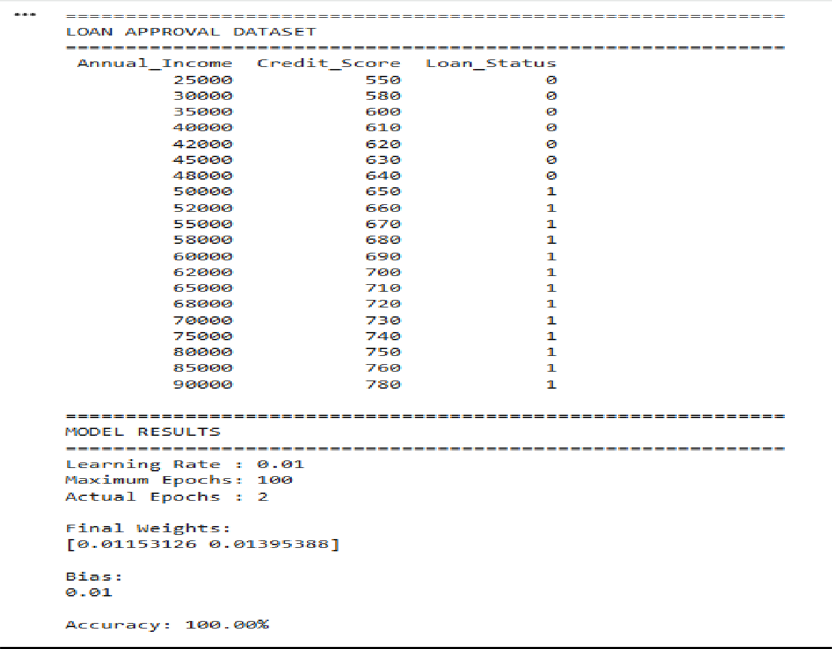

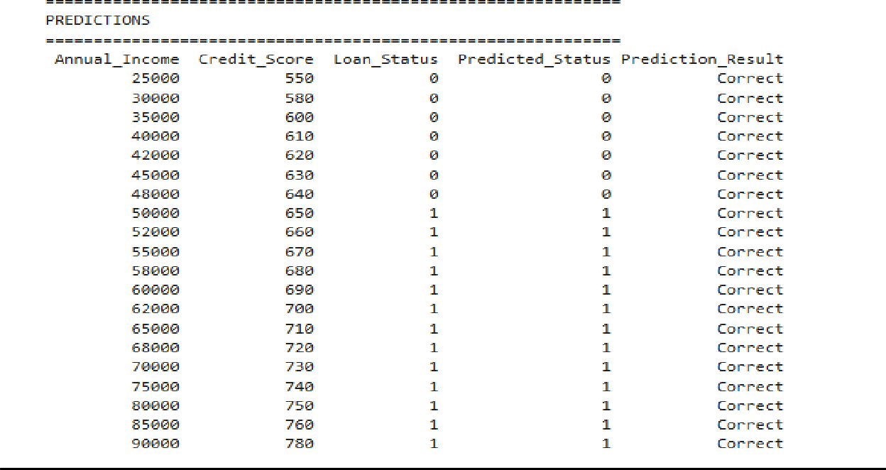

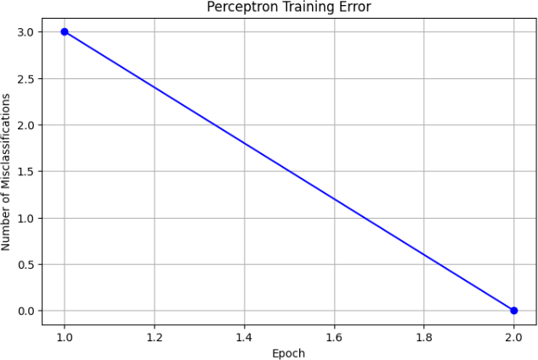
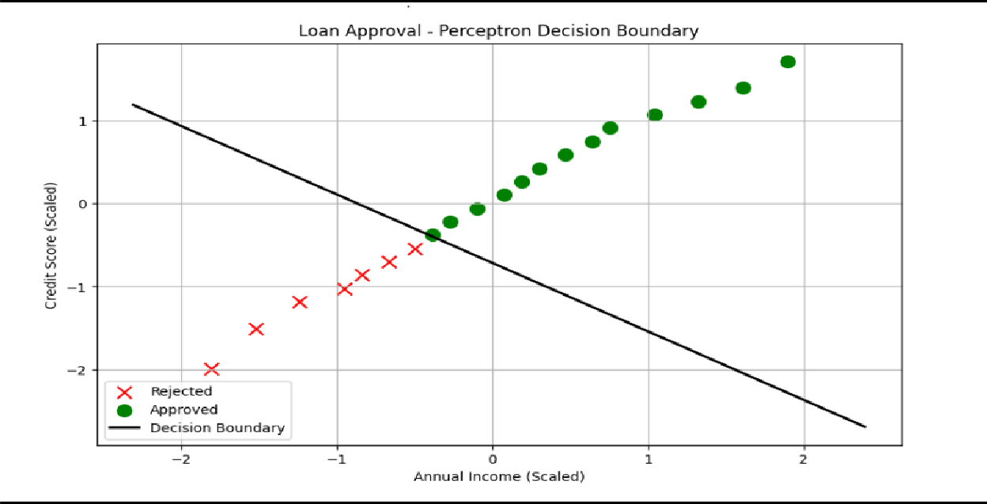
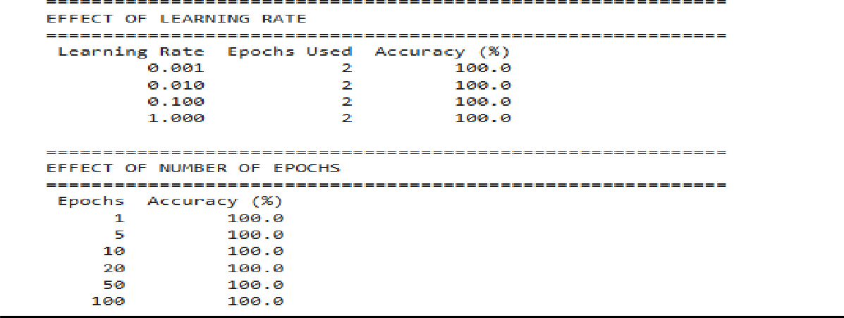

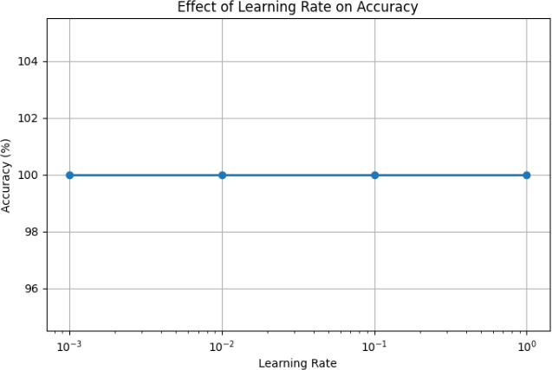
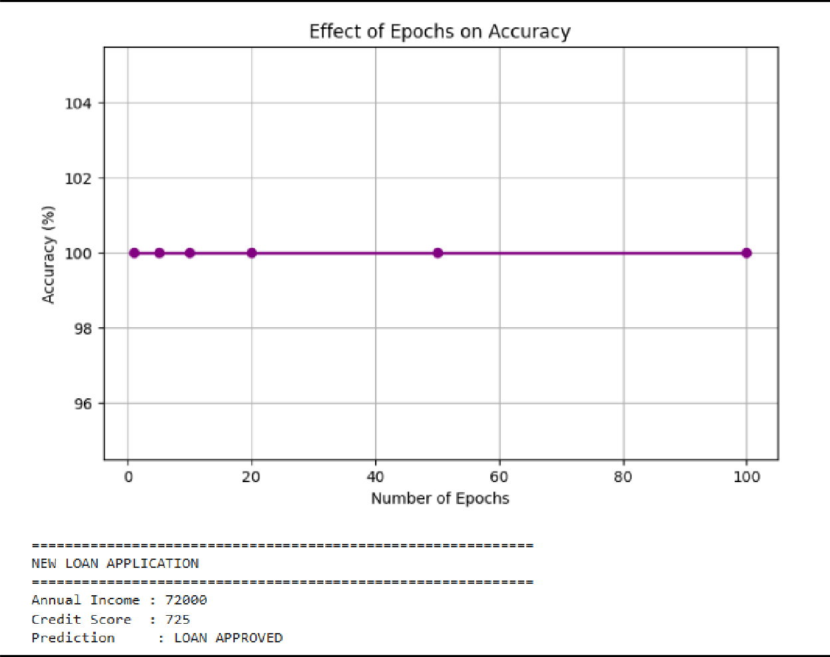

PRACTICAL :-2

Practical 2.1:-

Adaptive Linear Neuron (ADALINE) for House Price Prediction

Problem Statement:-

Implement an ADALINE network using the Delta Learning Rule to predict house prices based on area, number of rooms, and location score.

Objectives:-

Understand Widrow-Hoff learning. Compare ADALINE with Perceptron. Study Mean Squared Error minimization. Tools:-
Python, Pandas, NumPy

Source Code:-

import numpy as np import pandas as pd

# Sample dataset data = {
"Area": [1000, 1200, 1500, 1800, 2000],
"Rooms": [2, 3, 3, 4, 4],
"Location": [5, 6, 7, 8, 9],
"Price": [200, 250, 300, 360, 400]
}
df = pd.DataFrame(data) # Input and Output
X = df[["Area", "Rooms", "Location"]].values y = df["Price"].values

# Normalize data
X = X / X.max(axis=0) y = y / y.max()

# Add bias
X = np.c_[np.ones(len(X)), X]

# ADALINE Training
weights = np.zeros(X.shape[1]) lr = 0.1
epochs = 50

for epoch in range(epochs): output = np.dot(X, weights) error = y - output
weights += lr * np.dot(X.T, error) / len(X)

# Predictions
pred = np.dot(X, weights)

print("Actual Price\tPredicted Price") for a, p in zip(y, pred):
print(f"{a:.3f}\t\t{p:.3f}")

mse = np.mean((y - pred) ** 2) print("\nFinal Weights:", weights) print("Mean Squared Error:", round(mse, 5))

OUTPUT :-
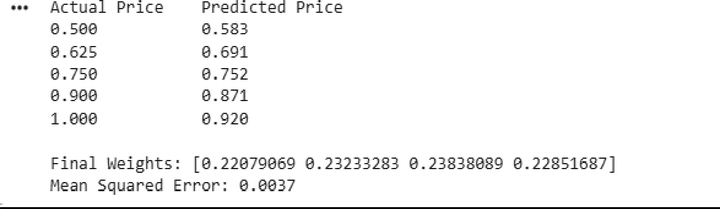

2.2 Loan Approval Prediction:-

Problem Statement:-

A financial institution wants to automate the loan approval process based on customer information such as annual income, credit score, employment experience, and existing loan amount. Develop an ADALINE network using the Delta Learning Rule to classify loan applications as Approved (1) or Rejected (0).

Features:-

- Annual Income

- Credit Score

- Years of Employment

- Existing Loan Amount Output:-
- 1 → Approved

- 0 → Rejected Source Code:-
import numpy as np import pandas as pd
# Loan Approval Dataset data = {
"Income": [30,40,50,60,70,80,90],
"CreditScore": [550,600,620,680,700,780,820],
"Experience": [1,2,3,4,5,6,7],
"LoanAmount": [25,30,40,45,50,55,60],
"Approval": [0,0,0,1,1,1,1]
}
df = pd.DataFrame(data) print(df)
# Input and Output
X = df[["Income", "CreditScore", "Experience", "LoanAmount"]].values y = df["Approval"].values

# Normalize Inputs import numpy as np

# Normalize Inputs
X = X / X.max(axis=0)

# Add Bias Column
X = np.c_[np.ones(len(X)), X]

# ADALINE Parameters weights = np.zeros(X.shape[1]) learning_rate = 0.1
epochs = 30

print("\nInitial Weights") print(weights)

# Training
for epoch in range(epochs): output = np.dot(X, weights) error = y - output
weights += learning_rate * np.dot(X.T, error) / len(X) mse = np.mean(error ** 2)

if (epoch + 1) % 5 == 0:
print(f"Epoch {epoch+1:2d} MSE = {mse:.4f}")

# Prediction
prediction = np.dot(X, weights)

# Threshold
predicted_class = (prediction >= 0.5).astype(int)

print("\nFinal Weights") print(weights)

print("\nPrediction Results") print("Actual\tOutput\tPredicted Class")

for actual, out, pred in zip(y, prediction, predicted_class): print(f"{actual}\t{out:.3f}\t{pred}")

accuracy = np.mean(predicted_class == y) * 100

print("\nFinal Mean Squared Error :", round(np.mean((y - prediction) ** 2), 4)) print("Accuracy :", round(accuracy, 2), "%")

OUTPUT :-
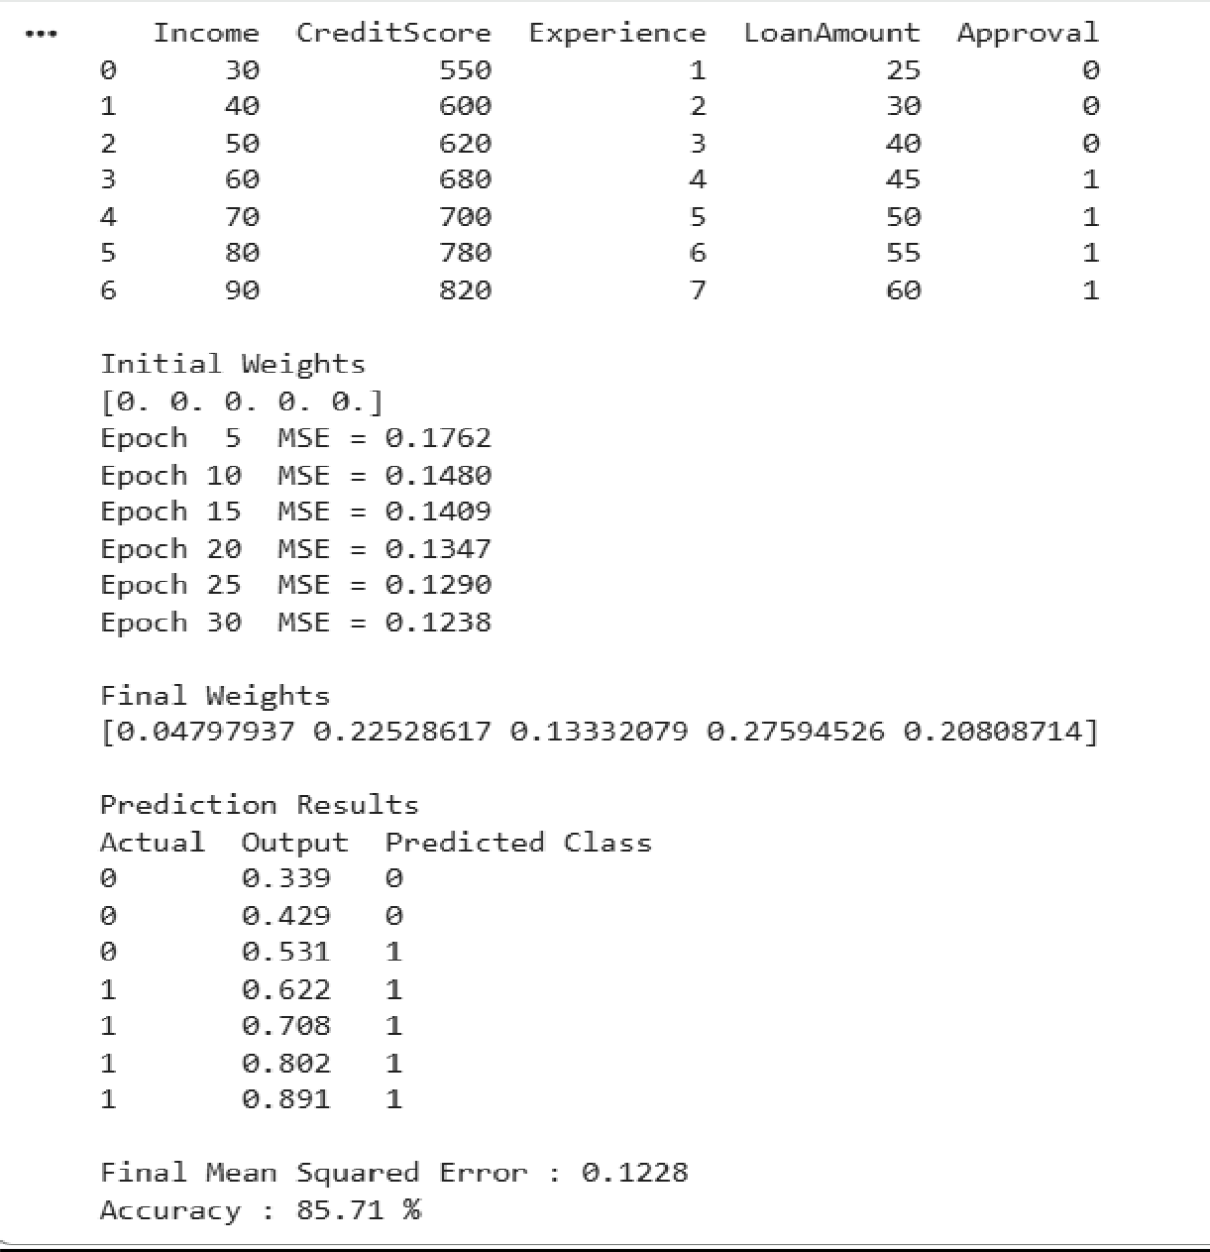

PRACTICAL :-3
Practical 3:-

Problem Statement:-

A smart traffic management system receives two fuzzy inputs:
- Degree of Traffic Congestion

- Degree of Road Occupancy

Both values are represented as membership values between 0 and 1.
Implement fuzzy logic operators to assist the traffic controller in evaluating road conditions.

Input:-

Traffic Congestion = 0.75 Road Occupancy = 0.62

Output:-

Traffic AND Occupancy Traffic OR Occupancy NOT Traffic
NOT Occupancy

Source Code:-

import matplotlib.pyplot as plt

print("=" * 60)
print(" SMART TRAFFIC MANAGEMENT USING FUZZY LOGIC")
print("=" * 60)
print("\nEnter membership values between 0 and 1.")

# Input
traffic = float(input("Traffic Congestion Membership (0-1): ")) occupancy = float(input("Road Occupancy Membership (0-1): "))

# Validation
if not (0 <= traffic <= 1 and 0 <= occupancy <= 1):
print("\nError! Membership values must be between 0 and 1.") exit()

#
# Fuzzy Operations #
fuzzy_and = min(traffic, occupancy) fuzzy_or = max(traffic, occupancy) not_traffic = 1 - traffic not_occupancy = 1 - occupancy

#
# Display Results #
print("\n" + "=" * 60)
print(" FUZZY OPERATION RESULTS")
print("=" * 60)
print(f"Traffic Congestion Membership : {traffic:.2f}") print(f"Road Occupancy Membership : {occupancy:.2f}") print("\nFuzzy AND (Minimum) :", round(fuzzy_and, 2)) print("Fuzzy OR (Maximum) :", round(fuzzy_or, 2)) print("NOT Traffic :", round(not_traffic, 2)) print("NOT Occupancy :", round(not_occupancy, 2))

print("\nInterpretation") print("-" * 60)
if fuzzy_and > 0.7:
print("Road is highly congested and highly occupied.") elif fuzzy_and > 0.4:
print("Road has moderate congestion.") else:
print("Road congestion is comparatively low.")

#
# Visualization #
labels = [ "Traffic", "Occupancy", "AND",

"OR",
"NOT Traffic", "NOT Occupancy",
]
values = [ traffic, occupancy, fuzzy_and, fuzzy_or, not_traffic,
not_occupancy,
]

plt.figure(figsize=(8, 5))
bars = plt.bar(labels, values) plt.ylim(0, 1.1) plt.ylabel("Membership Value") plt.xlabel("Fuzzy Operations")
plt.title("Smart Traffic Control using Fuzzy Logic")

# Show values on top of bars for bar in bars:
height = bar.get_height() plt.text(
bar.get_x() + bar.get_width() / 2, height + 0.02,
f"{height:.2f}", ha="center",
)

plt.grid(axis="y", linestyle="--") plt.show()

OUTPUT:-
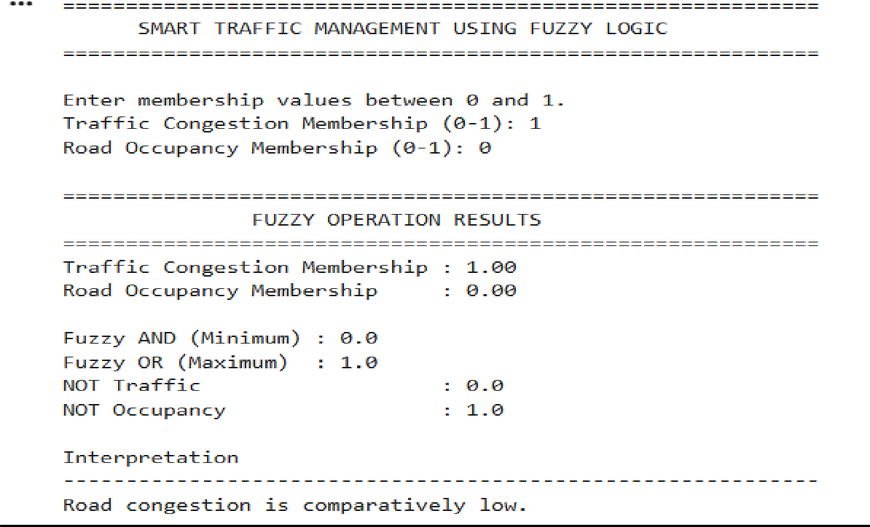

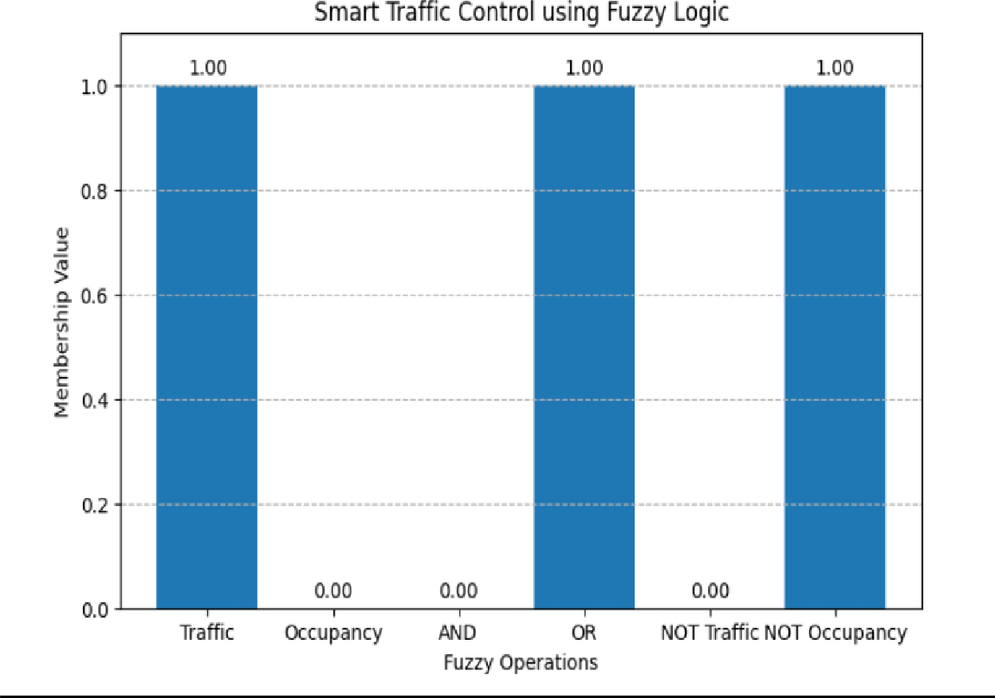

PRACTICAL :- 4

Practical-4
Pratical Source Code:-
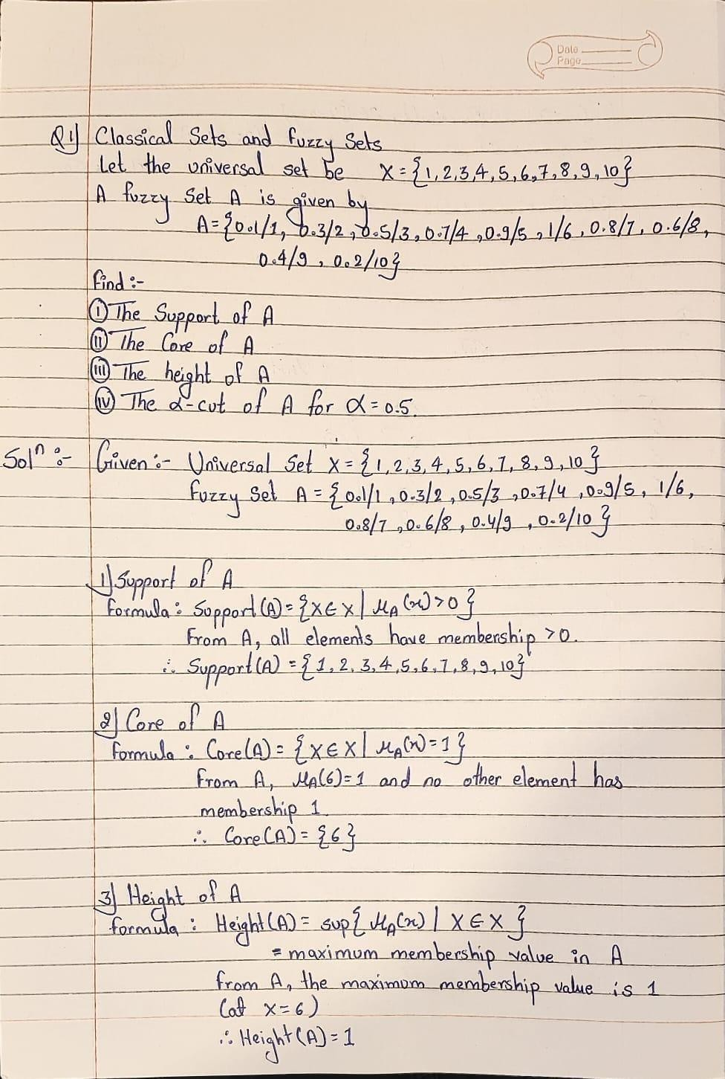

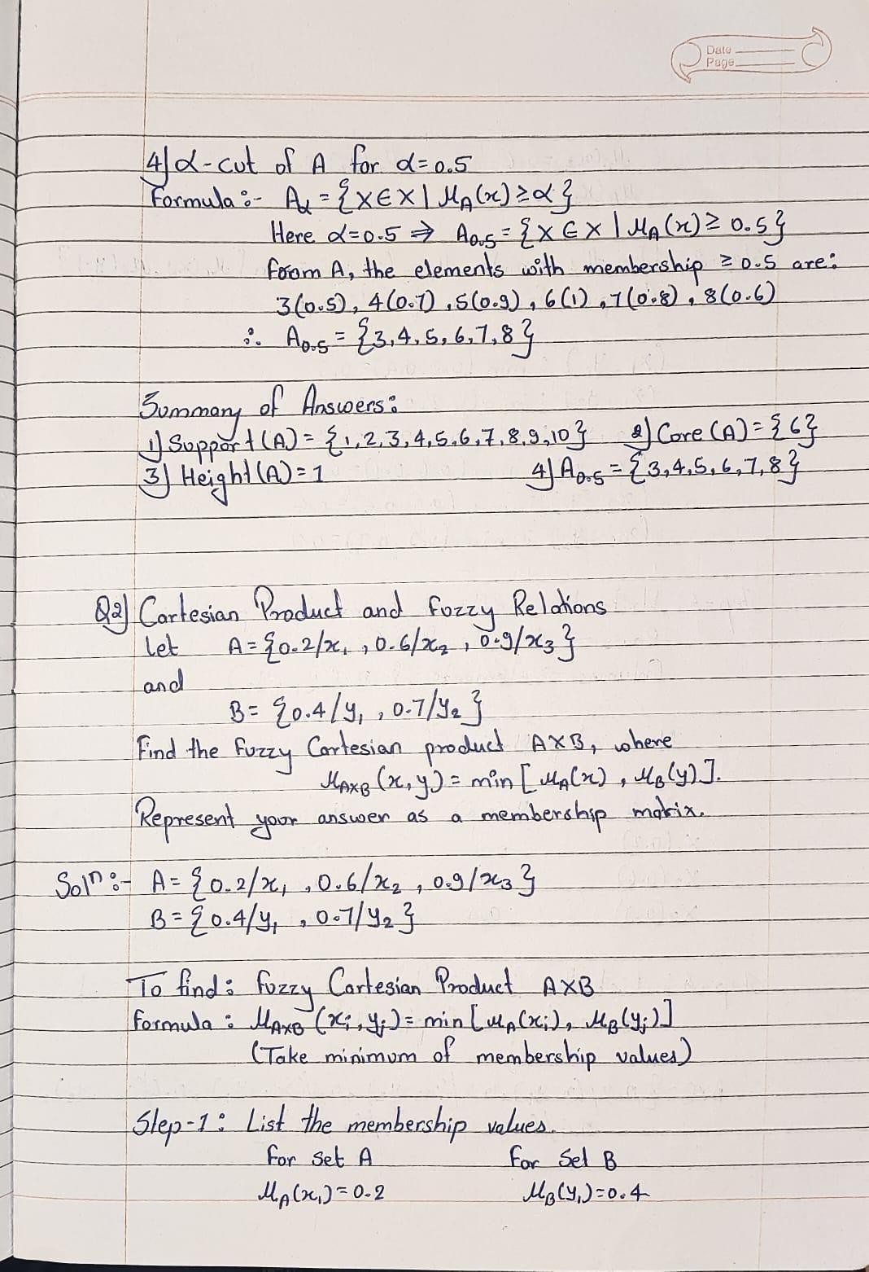

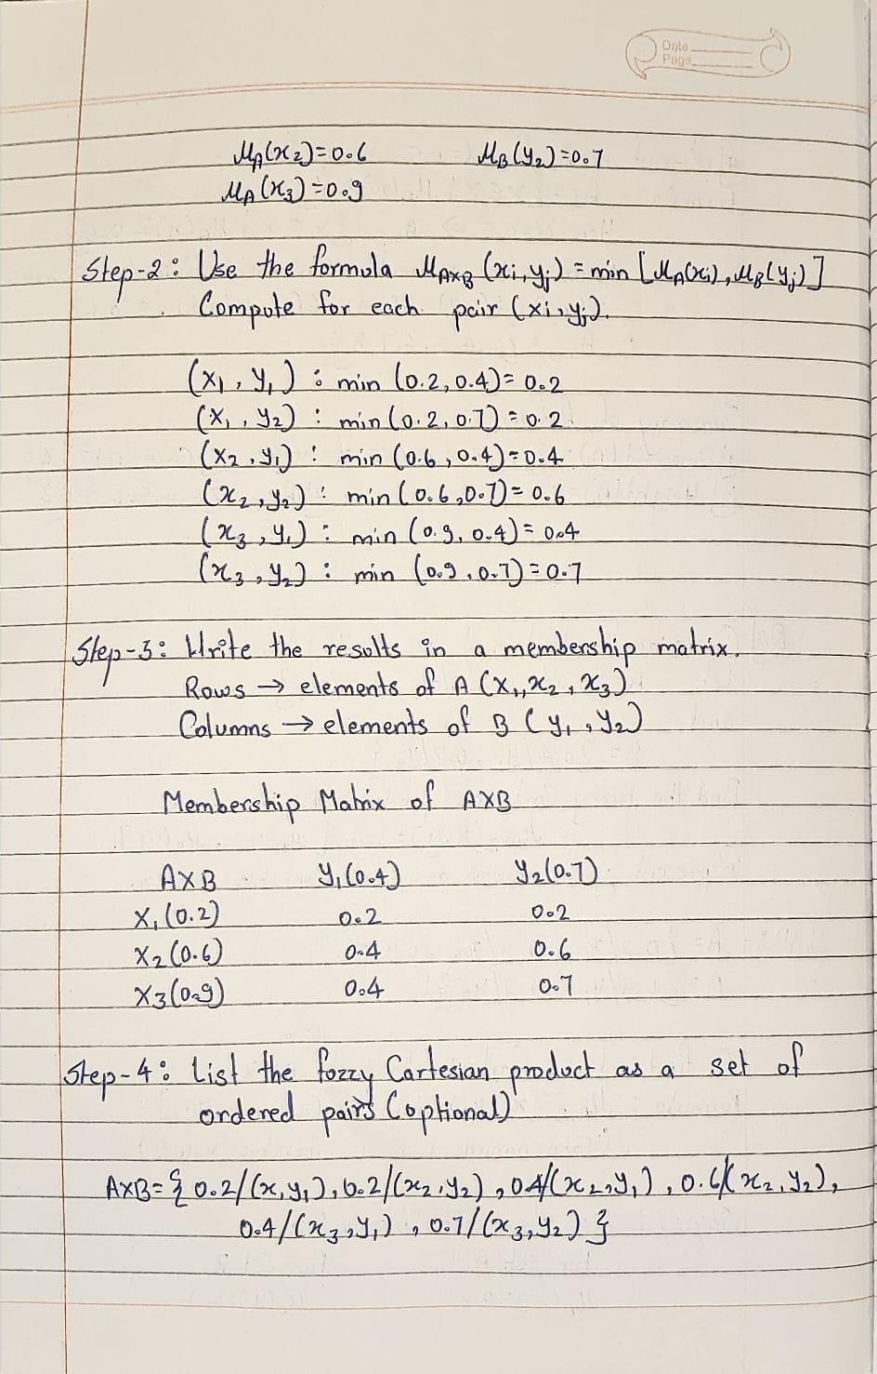

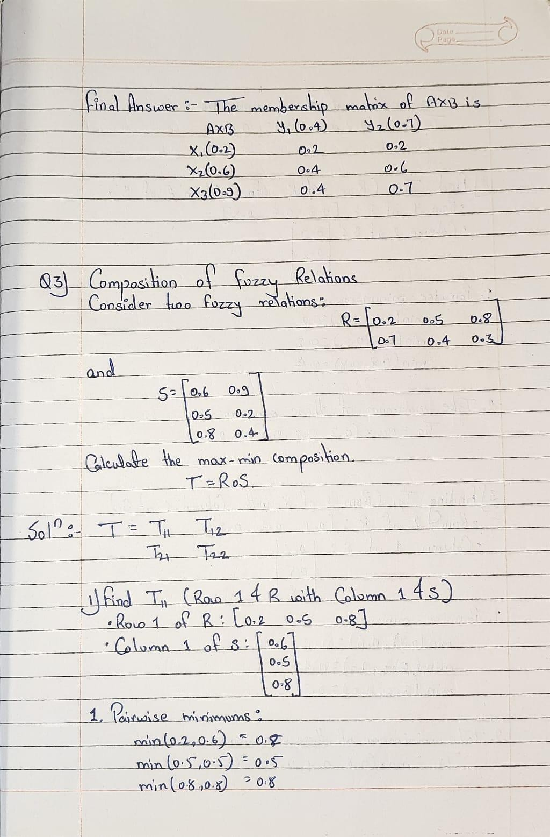

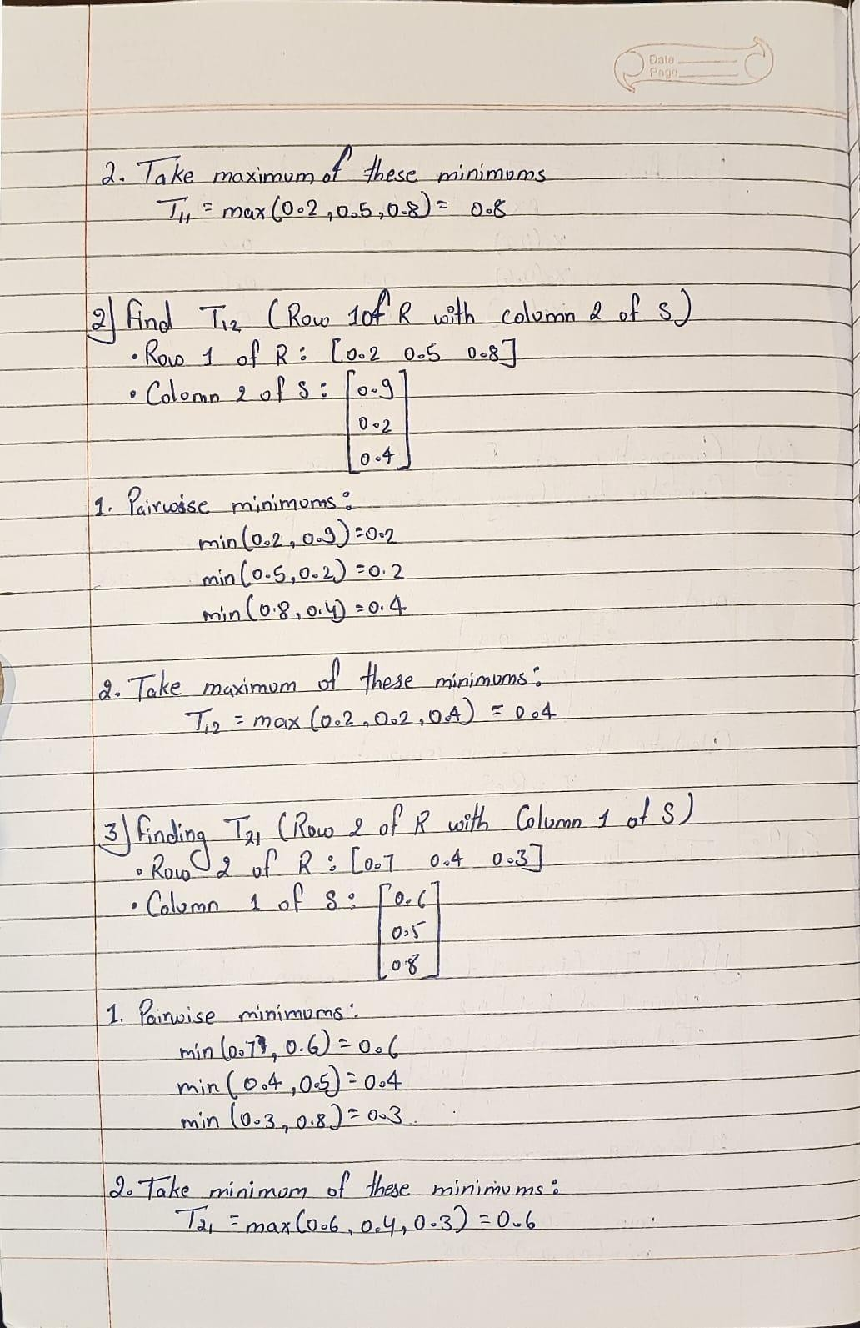

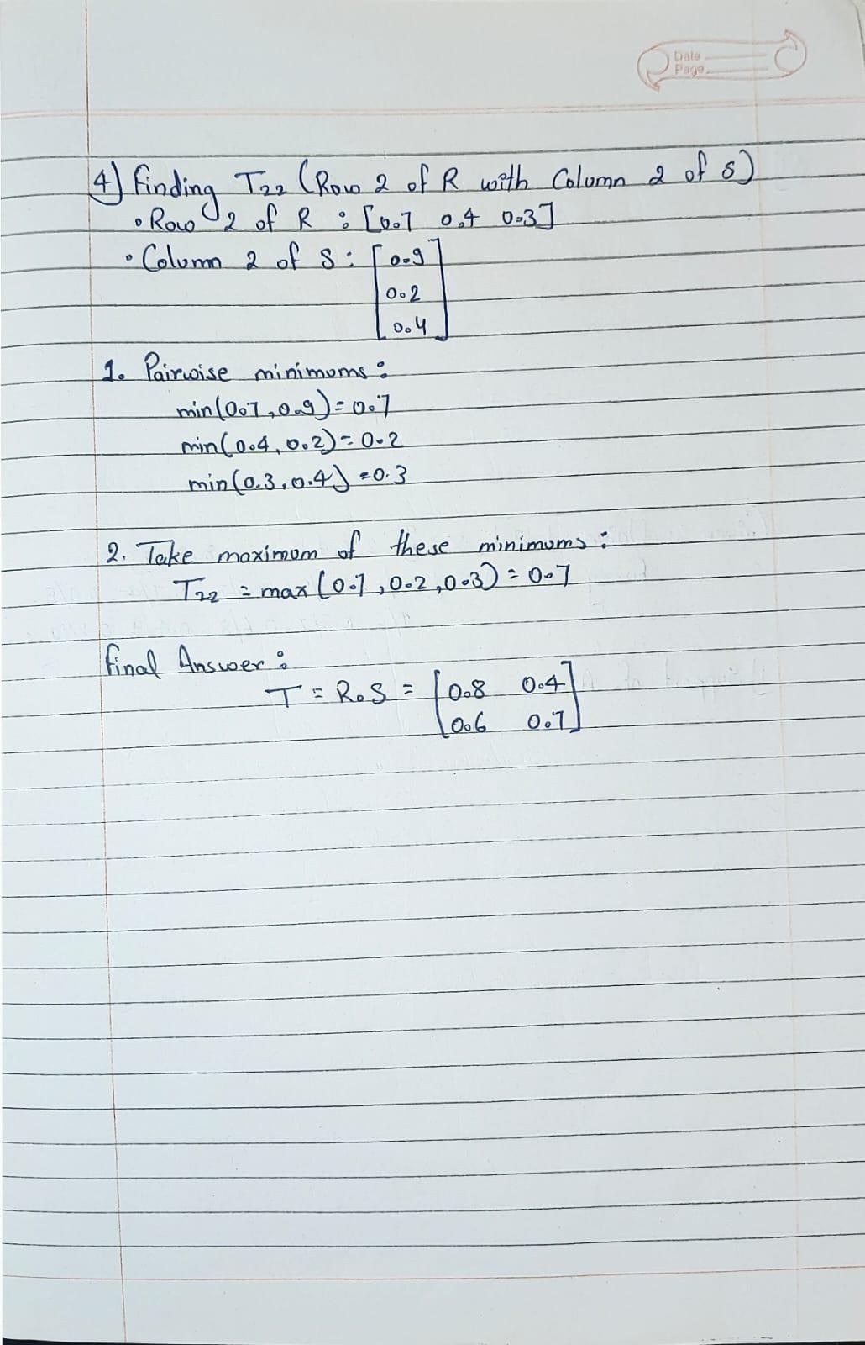

PRACTICAL :- 5

Practical-5
AIM:-To develop a customer segmentation model using a Self-Organizing Map (SOM) by transforming raw retail transaction data into customer behavioral features, training an unsupervised neural network to discover natural customer groups, and interpreting the identified segments for business decision-making.

Source Code:-

import pandas as pd import numpy as np
import matplotlib.pyplot as plt
from sklearn.preprocessing import MinMaxScaler from sklearn.cluster import KMeans
from minisom import MiniSom

excel_file = pd.ExcelFile('online_retail_II.xlsx') print(excel_file.sheet_names)

df1 = pd.read_excel(excel_file, sheet_name='Year 2009-2010') df2 = pd.read_excel(excel_file, sheet_name='Year 2010-2011') df = pd.concat([df1, df2], ignore_index=True)

df.head() df.shape df.info() df.describe() df.columns
df.isnull().sum()

df = df.dropna(subset=['Customer ID'])
df = df[~df['Invoice'].astype(str).str.startswith('C')] df = df[df['Quantity'] > 0] df = df[df['Price'] > 0]
df['InvoiceDate'] = pd.to_datetime(df['InvoiceDate']) df['TotalAmount'] = df['Quantity'] * df['Price']
snapshot_date = df['InvoiceDate'].max() + pd.Timedelta(days=1) recency = (snapshot_date - df.groupby('Customer ID')['InvoiceDate'].max()).dt.days
frequency = df.groupby('Customer ID')['Invoice'].nunique()

monetary = df.groupby('Customer ID')['TotalAmount'].sum() avg_order_value = monetary / frequency
unique_products = df.groupby('Customer ID')['StockCode'].nunique() total_quantity = df.groupby('Customer ID')['Quantity'].sum() customer_data = pd.DataFrame({ 'Recency': recency, 'Frequency':
frequency, 'Monetary': monetary,
'AvgOrderValue': avg_order_value, 'UniqueProducts': unique_products, 'TotalQuantity': total_quantity
})

customer_data.reset_index(inplace=True)

customer_data.head() customer_data.describe()

X = customer_data.drop(columns=['Customer ID']) scaler = MinMaxScaler()
X_scaled = scaler.fit_transform(X)
!pip install minisom som = MiniSom(
x=10, y=10,
input_len=X_scaled.shape[1],

sigma=1.0, learning_rate=0.5, random_seed=42) som.random_weights_init(X_scaled) som.train_random(

data=X_scaled,

num_iteration=5000) plt.figure(figsize=(10,8)) plt.pcolor(som.distance_map().T, cmap='bone_r') plt.colorbar() plt.title("U-Matrix") plt.show()
winner_coordinates = np.array( [som.winner(x) for x in X_scaled])
customer_data["SOM_X"] = winner_coordinates[:,0]

customer_data["SOM_Y"] = winner_coordinates[:,1]

from collections import Counter
hits = Counter(map(tuple, winner_coordinates))

print(hits)
weights = som.get_weights()
weight_vectors = weights.reshape(-1, weights.shape[2]) kmeans = KMeans(n_clusters=4, random_state=42)

kmeans.fit(weight_vectors) neuron_clusters = kmeans.labels_
neuron_clusters = neuron_clusters.reshape(10,10) customer_clusters = []
for customer in X_scaled:
x, y = som.winner(customer) customer_clusters.append(neuron_clusters[x, y])

customer_data["Cluster"] = customer_clusters customer_data.groupby("Cluster").mean(numeric_only=True) customer_data["Cluster"].value_counts() customer_data.to_csv("Customer_Segments.csv",index=False)

customer_data.head()

OUTPUT:-

['Year 2009-2010', 'Year 2010-2011']
<class 'pandas.core.frame.DataFrame'> RangeIndex: 1067371 entries, 0 to 1067370 Data columns (total 8 columns):
# Column Non-Null Count Dtype

- Invoice 1067371 non-null object
- StockCode 1067371 non-null object
- Description 1062989 non-null object
- Quantity 1067371 non-null int64
- InvoiceDate 1067371 non-null datetime64[ns]

- Price 1067371 non-null float64
- Customer ID 824364 non-null float64
- Country 1067371 non-null object
dtypes: datetime64[ns](1), float64(2), int64(1), object(4) memory usage: 65.1+ MB

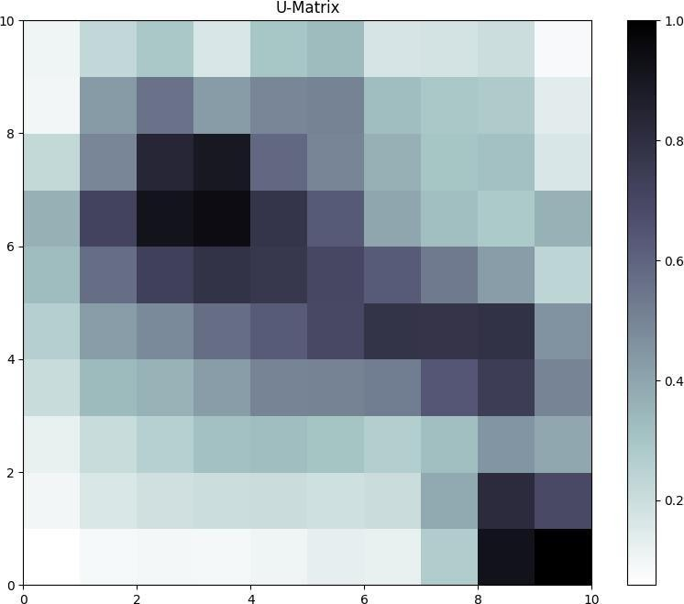

 | Custome  r ID | Recency | Frequency | Monetary | AvgOrde r Value | Unique Products | Total Quanti ty | SOM_X | SOM_Y | Cluster
0 | 12346.0 | 326 | 12 | 77556.46 | 6463.038 | 27 | 74285 | 9 | 6 | 2
1 | 12347.0 | 2 | 8 | 5633.32 | 704.1650 | 126 | 3286 | 4 | 0 | 3
2 | 12348.0 | 75 | 5 | 2019.40 | 403.8800 | 25 | 2714 | 2 | 2 | 3
3 | 12349.0 | 19 | 4 | 4428.69 | 1107.1725 | 138 | 1624 | 5 | 1 | 3
4 | 12350.0 | 310 | 1 | 334.40 | 334.4000 | 17 | 197 | 9 | 7 | 1

PRACTICAL NO:06
PRACTICAL 6:-

AIM:-
Experimental Analysis of a Hopfield Neural Network for Binary Pattern Storage, Associative Retrieval, Energy Minimization, and Noise Tolerance.

SourceCode:
import numpy as np
import matplotlib.pyplot as plt

patterns = { "A": np.array([
[-1, |  | 1, 1, 1, -1],
[ 1, |  | -1, -1, -1, 1],
[ 1, |  | 1, 1, 1, 1],
[ 1, |  | -1, -1, -1, 1],
[ 1, |  | -1, -1, -1, 1]
]),
"B": np.array([
[ | 1, | 1, 1, 1, -1],
[ | 1, | -1, -1, -1, 1],
[ | 1, | 1, 1, 1, -1],
[ | 1, | -1, -1, -1, 1],
[ | 1, | 1, 1, 1, -1]
]),
"C": np.array([
[-1, |  | 1, 1, 1, 1],
[ 1, |  | -1, -1, -1, -1],
[ 1, |  | -1, -1, -1, -1],

[ 1, -1, -1, -1, -1],
[-1, 1, 1, 1, 1]
])

}

def
display_pattern(pattern, title): plt.figure(figsize=(3, 3)) plt.imshow( pattern,
cmap="gray ", vmin=-1, vmax=1
)
plt.title(titl e) plt.axis("off"
) plt.show()

print("=" * 60)
print(" HOPFIELD NEURAL NETWORK") print(" INTERACTIVE LEARNING SYSTEM")
print("=" * 60)

print("\nThe network has learned these patterns:") for name, pattern in patterns.items():

print("\nPattern", name) print(pattern)

pattern_vectors = []

for pattern in patterns.values(): pattern_vectors.append( pattern.flatten()
)

number_of_neurons = pattern_vectors[0].size W
= np.zeros(
(number_of_neurons, number_of_neurons)
)

for pattern in pattern_vectors: W
+=
np.outer( pattern, pattern
)

np.fill_diagonal(W, 0)

W = W / number_of_neurons

print("\n ")
print("NETWORK INFORMATION")

print(" ")
print("Number of stored patterns :", len(patterns)) print("Image size : 5 × 5")
print("Number of neurons :", number_of_neurons) print("Weight matrix
:", W.shape)
def
calculate_energy(st ate): state = state.flatten() energy = -0.5 * np.dot(
state, np.dot(W, state)

)
return energy

def
update_network(stat e): new_state = state.copy() for i in range(len(state)):
activation = np.dot( W[i], new_state
)
if activation >=

0: new_state[i] =
1
else:
new_state[i] = -1 return new_state

def retrieve_pattern(input_pattern, max_iterations=20): state
=
input_pattern.flatten()
.copy() energy_history
= [
calculate_energy(state)
]

for iteration in range(max_iterations): new_state =
update_network(state) energy_history.append(
calculate_energy(new_state)
)

if np.array_equa l( new_state,

state
):
return ( new_state.reshape(5

, 5),
energy_history, iteration + 1
)
state = new_state return
(
state.reshape(5
, 5),
energy_history, max_iterations
)

def calculate_accuracy(original, retrieved): correct = np.sum( original == retrieved
)
total = original.size return ( correct / total
) * 100
def add_noise(pattern, noise_percentage): noisy = pattern.copy() total_pixels = noisy.size
number_of_pixels = int( total_pixels *
noise_percentage / 100

)
if number_of_pixels
== 0: return noisy indices =

np.random.choice( total_pixels, number_of_pixels, replace=False
)
flat = noisy.flatten() flat[indices] *= -1
return flat.reshape(5, 5)

def
display_result (
input_pattern, retrieved_patt ern, title
):
plt.figure(figsize=(9, 3)) plt.subplot(1,
2, 1)
plt.imshow( input_pattern
,
cmap="gray", vmin=-1, vmax=1
)
plt.title("Input Pattern") plt.axis("off")

plt.subplot(1, 2,
2) plt.imshow(

retrieved_pat tern, cmap="gray", vmin=-1, vmax=1
)
plt.title("Hopfield
Retrieved Pattern")
plt.axis("off") plt.suptitle(t itle) plt.tight_layo ut() plt.show()

while True: print("\n")
print("=" * 60) print(" MAIN MENU")
print("=" * 60)
print("1. Test a stored pattern with noise") print("2. Enter your own 5×5 pattern") print("3. Display stored patterns") print("4. Exit")

choice = input(
"\nEnter your choice (1-4): "
)
if choice == "1":
print("\nAvailable stored patterns:") for name in patterns:

print(" ", name)

pattern_name = input(
"\nWhich pattern do you want to test? "
).upper()
if pattern_name not in patterns: print(
"\nInvalid pattern name."
)
continue

try:

noise = float( input( "Enter noise
percentage " "(0-
80): "

)
)
except:
print(
"\nPlease enter a valid number."
)
continue

if noise < 0 or noise > 80: print(
"\nNoise must be between 0 and 80."
)
continue

original = patterns[ pattern_name
]
noisy_input = add_noise( original,
noise
)

retrieved, energy_history, iterations = ( retrieve_pattern( noisy_input
)
)

accuracy = calculate_accuracy( original, retrieved
)

print("\n")
print("=" * 60)
print(" RETRIEVAL RESULT")
print("=" * 60) print(
"\nOriginal Pattern:"
)
print(origina l) print(

"\nNoisy Input:"
)
print(noisy_input) print( "\nRetrieved Pattern:"
)
print(retrieved) print( f"\nRetrieval Accuracy: " f"{accuracy:.2f}%"
)
print(
f"Iterations to Converge: " f"{iterations}"

)
print(
f"Initial Energy: " f"{energy_history[0]:.2f}"
)
print(
f"Final Energy: " f"{energy_history[-1]:.2f}"
)

display_res ult( noisy_inp ut, retrieved
,
f"Noise = {noise}%"
)

plt.figure(figsiz e=(7, 4))
plt.plot( energy_history, marker="o"
)
plt.xlabel( "Iteration"
)

plt.ylabel( "Energy"
)
plt.title(
"Energy Minimization"
)
plt.grid(True) plt.show()

elif choice == "2": print("\n")
print("=" * 60)
print(" ENTER YOUR OWN 5×5 PATTERN")
print("=" * 60) print(
"\nEnter 5 rows."
)
print(

"Use 1 for ON and -1 for OFF."
)
print(
"Example: 1 1 -1 -1 1"
)

user_pattern = [] valid_input = True
for row_number in range(5): row = input(
f"Row {row_number + 1}: "

)
try:
values
= [
int(x)
for x in row.split()
]
if len(values) != 5: print(
"\nEach row must contain " "exactly 5 values."
)
valid_input =
False break if not all(
x in [-1, 1] for x in values
):
print(

"\nOnly -1 and 1 are allowed."
)
valid_input = False break user_pattern.appe nd(
values
)
except: print(

"\nInvalid input."
)
valid_input = False break

if not valid_input: continue

user_pattern = np.array( user_pattern
)

print("\nYour input pattern:") print(user_pattern) retrieved, energy_history,
iterations = ( retrieve_pattern( user_pattern
)
)

print(
"\nHopfield Retrieved Pattern:"
)
print(retrieved) print( f"\nIterations to Converge: " f"{iterations}"
)
print(
f"Initial Energy: " f"{energy_history[0]:.2f}"
)

print(
f"Final Energy: " f"{energy_history[-1]:.2f}"
)

display_result( user_pattern, retrieved,
"Student Input → Hopfield Retrieval"
)
plt.figure(figsize=(7, 4)) plt.plot( energy_history,
marker="o"
)
plt.xlabel(

"Iteration"
)
plt.ylabel( "Energy"
)
plt.title(
"Energy During Retrieval"
)
plt.grid(True) plt.show() elif choice == "3":
print("\nStored Memories:") for name, pattern in

patterns.items(): display_pattern( pattern,
f"Stored Pattern {name}"
)
elif choice == "4": print(
"\nThank you for using the " "Hopfield Neural Network!"
)

break
else:
print(
"\nPlease enter 1, 2, 3 or 4."
)
Output:-
\
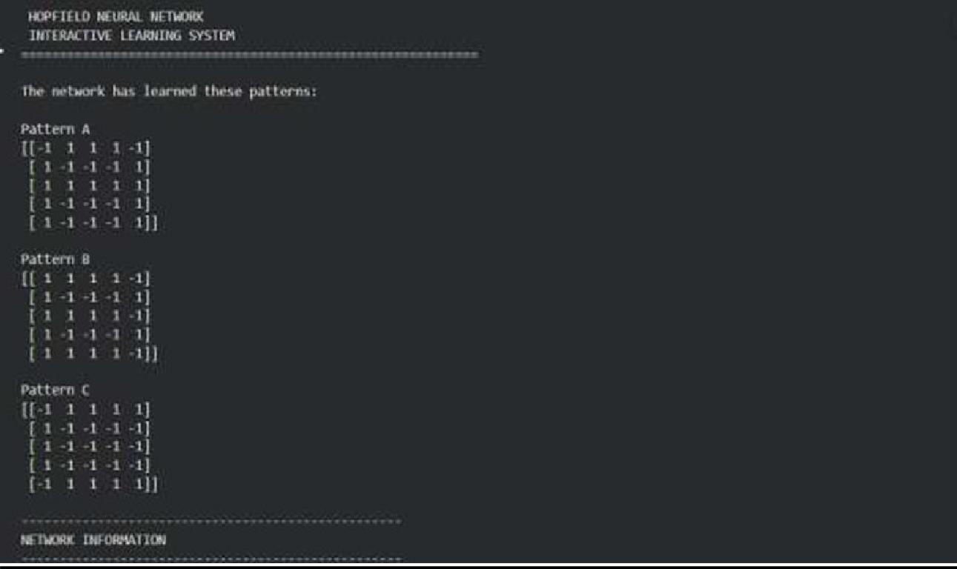

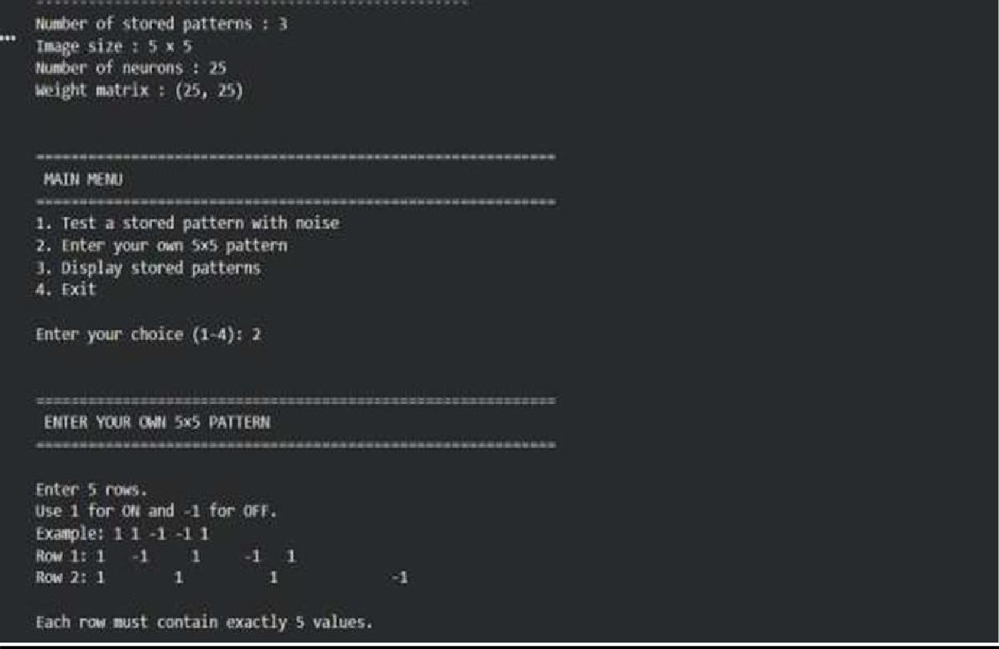

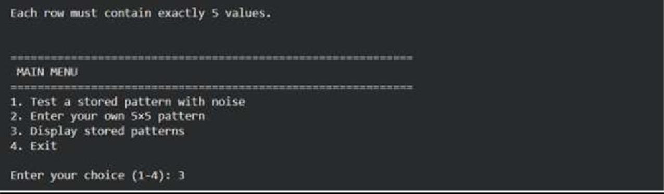
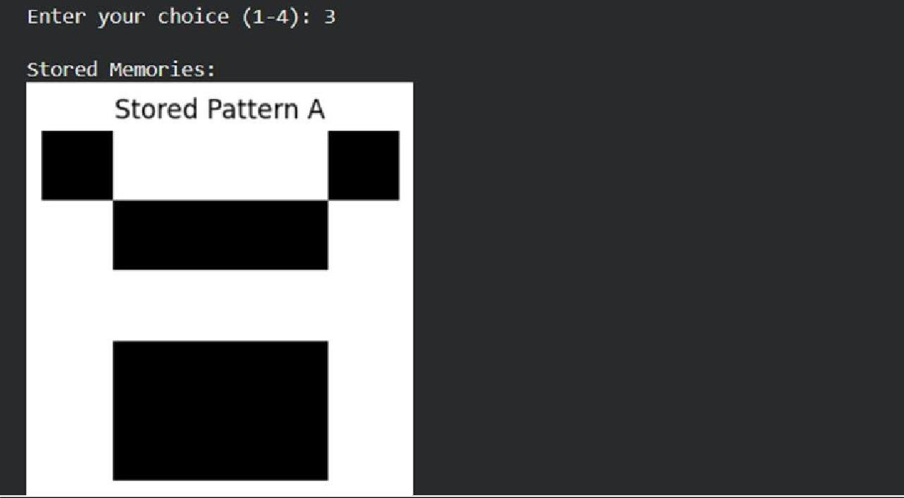

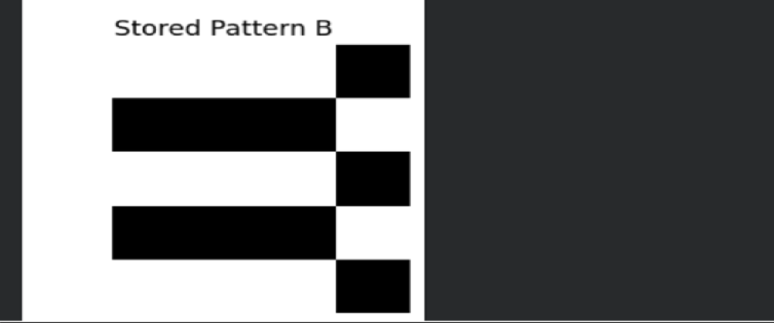

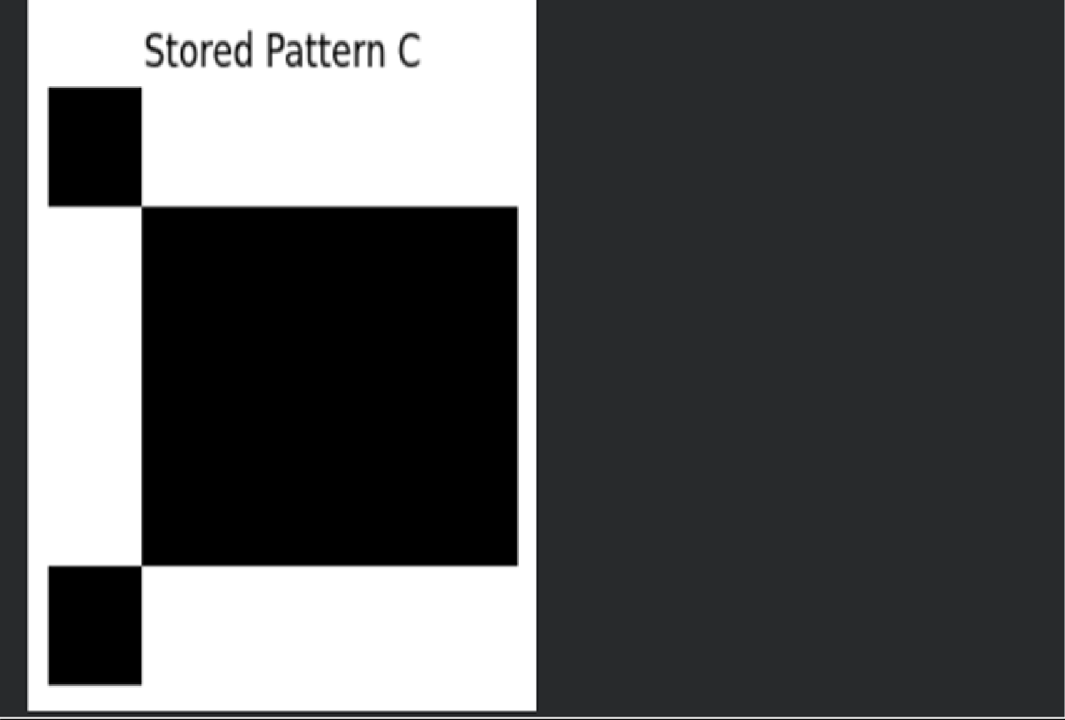

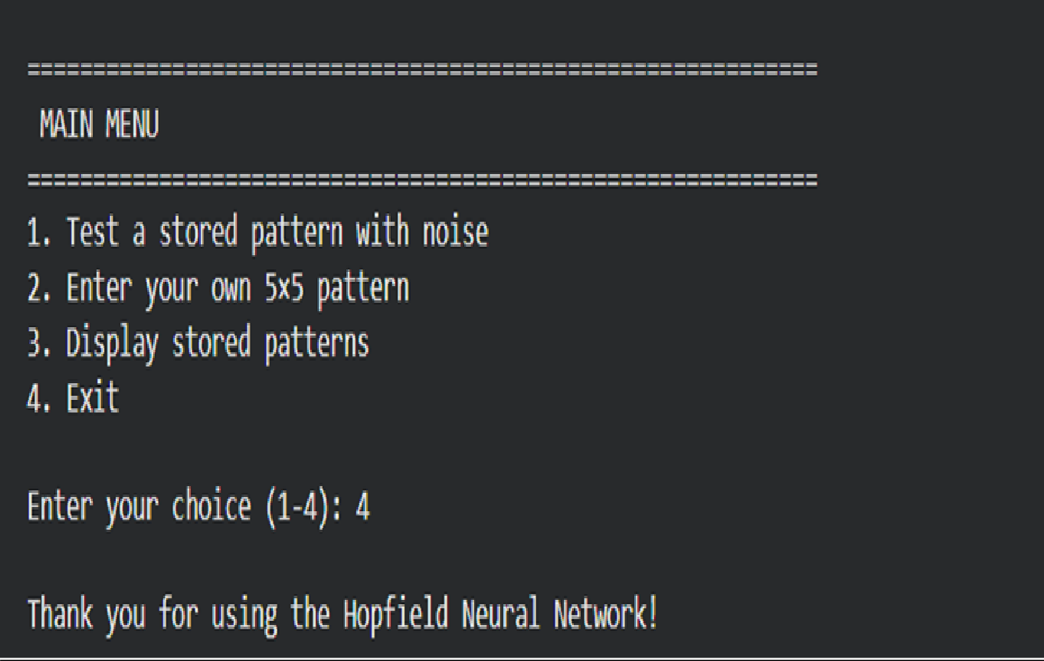

# EXPERIMENTAL ANALYSIS OF A HOPFIELD NEURAL NETWORK USING MNIST
Source Code:
import numpy as np
import matplotlib.pyplot as plt
from tensorflow.keras.datasets import mnist

(x_train, y_train), (x_test, y_test) = mnist.load_data() print("MNIST DATASET") print("-" * 50)
print("Training images :", x_train.shape) print("Testing images :", x_test.shape)

plt.figure(figsize
=(10, 4)) for i in range(10):
plt.subplot(2, 5, i + 1) plt.imshow(
x_train[i], cmap="gray"
)
plt.title(
f"Digit: {y_train[i]}"
)
plt.axis("off"
)
plt.tight_layout () plt.show()

digit_to_store =
5 index =

np.where(
y_train == digit_to_store

)[0][0]
original_image = x_train[index]
print("\nSelected digit:", digit_to_store) print("Image shape:", original_image.shape)

from PIL import Image image_pil =
Image.fromarray( original_image
)

image_pil = image_pil.resize( (14,
14)
)
small_image = np.array( image_pil
)
print("\nResized image shape:") print(small_image.shape)

threshold = 80 binary_pattern = np.where(
small_image > threshold, 1,
-1
)
plt.figure(figsiz e=(4, 4))

plt.imshow( binary_patt ern, cmap="gray"
, vmin=-1,

vmax=1
)
plt.title(
"Binary MNIST Pattern"
)
plt.axis("off") plt.show()

stored_pattern = binary_pattern.flatten() number_of_neurons = len(
stored_pattern
)
print("\nNumber of Hopfield neurons:") print(number_of_neurons)

W = np.outer( stored_patter n, stored_patter n
)

np.fill_diag onal( W,
0

)

W = W / number_of_neurons print("\nWeight Matrix Shape:") print(W.shape)

def
calculate_energy(st ate): state = state.flatten() energy = -0.5 * np.dot(
state, np.dot(W, state)
)
return energy

def add_noise( pattern,
noise_percentage

):
noisy_pattern = pattern.copy() total_pixels
= len( noisy_pattern
)
number_of_noisy_pixels
= int( total_pixels * noise_percentage / 100
)

indices = np.random.choice( total_pixels, number_of_noisy_pixels, replace=False
)
noisy_pattern[indices
] *= -1 return noisy_pattern
def
update_network(stat e): new_state = state.copy() for i in range( len(state)
):
activation = np.dot( W[i], new_state
)
if activation >= 0: new_state[i] =
1
else:
new_state[i] = -1 return new_state

def retrieve_pattern( noisy_pattern, max_iterations=20
):
state = noisy_pattern.copy()

energy_history = []

energy_history.append( calculate_energy(state)
)
for iteration in range( max_iterations
):
new_state = update_network( state
)

energy_history.append( calculate_energy(
new_state
)
)

if np.array_equa l( new_state, state
):
print(
"\nNetwork converged at " f"iteration
{iteration + 1}"
)
break
state = new_state return
(

state, energy_histor
y
)

def
calculate_accuracy( original,
retrieved
):
correct_pixels = np.sum( original == retrieved
)
total_pixels = len( original
)
accuracy = (
correct_pix els / total_pixel s
) * 100

return accuracy

noise_percentage = 20 noisy_pattern = add_noise(
stored_pattern
,
noise_percenta

ge
)

retrieved_pattern, energy_history = ( retrieve_pattern(
noisy_pattern
)
)

accuracy = calculate_accuracy( stored_pattern,
retrieved_pattern
)
print("\n")
print("=" * 60) print("RETRIEVAL RESULTS")

print("=" * 60) print( "Noise Level :",
noise_percentage, "%"
)

print(
"Retrieval Accuracy :", round(accuracy, 2), "%"
)
print(
"Initial Energy :", round( energy_history[0], 2

)
)
print(
"Final Energy
:", round( energy_history[-1], 2
)
)

noisy_image = noisy_pattern.reshape( 14,
14

)
retrieved_image = retrieved_pattern.reshape( 14,
14

)

plt.figure( figsize=(12
, 4)
)
plt.subpl ot( 1,
3,
1
)
plt.imshow( binary_patt

ern, cmap="gray"
, vmin=-1, vmax=1
)
plt.title(
"Original Stored Pattern"
)
plt.axis("off") plt.subplot(
1,

3,
2
)

plt.imshow( noisy_image, cmap="gray",
vmin=-1, vmax=1
)

plt.title(
f"Noisy Input ({noise_percentage}%)"
)
plt.axis("off") plt.subplot(
1,
3,
3
)

plt.imshow(
retrieved_ima ge, cmap="gray", vmin=-1, vmax=1
)
plt.title( "Retrieved Pattern"
)
plt.axis("off")
plt.tight_layout () plt.show()

plt.figure(

figsize=(7, 4)
)
plt.plot( range(
len(energy_hist ory)
),
energy_history
, marker="o"
)

plt.xlabel( "Iteration"
)
plt.ylabel( "Energy"

)
plt.title(
"Hopfield Energy Minimization"
)
plt.grid ( True
)
plt.show()

noise_levels
= [ 0,
10,
20,
30,
40,

50
]
accuracies = [] for noise in
noise_levels: noisy
= add_noise( stored_pattern, noise
)
retrieved, energies = ( retrieve_pattern(
noisy
)
)

acc = calculate_accuracy( stored_pattern,
retrieved

)
accuracies.appe nd( acc
)

print("\n")
print("=" * 60)
print("NOISE TOLERANCE ANALYSIS")
print("=" * 60) print(
"\nNoise Level (%) Retrieval Accuracy (%)"
)
print(

"-" * 45)
for noise, accuracy_value in zip( noise_levels,
accuracies
):
print( f"{noise:^16} "
f"{accuracy_value:>10.2f}"
)

plt.figure( figsize=(7
, 4)
)

plt.plot(
noise_levels, accuracies, marker="o"
)
plt.xlabel(
"Noise Level (%)"
)
plt.ylabel(
"Retrieval Accuracy (%)"
)
plt.title(
"Hopfield Network Noise Tolerance"
)
plt.grid( True
)
plt.show() print("\n")
print("=" * 60) print("EXPERIMENT COMPLETED")
print("=" * 60)

OUTPUT:-
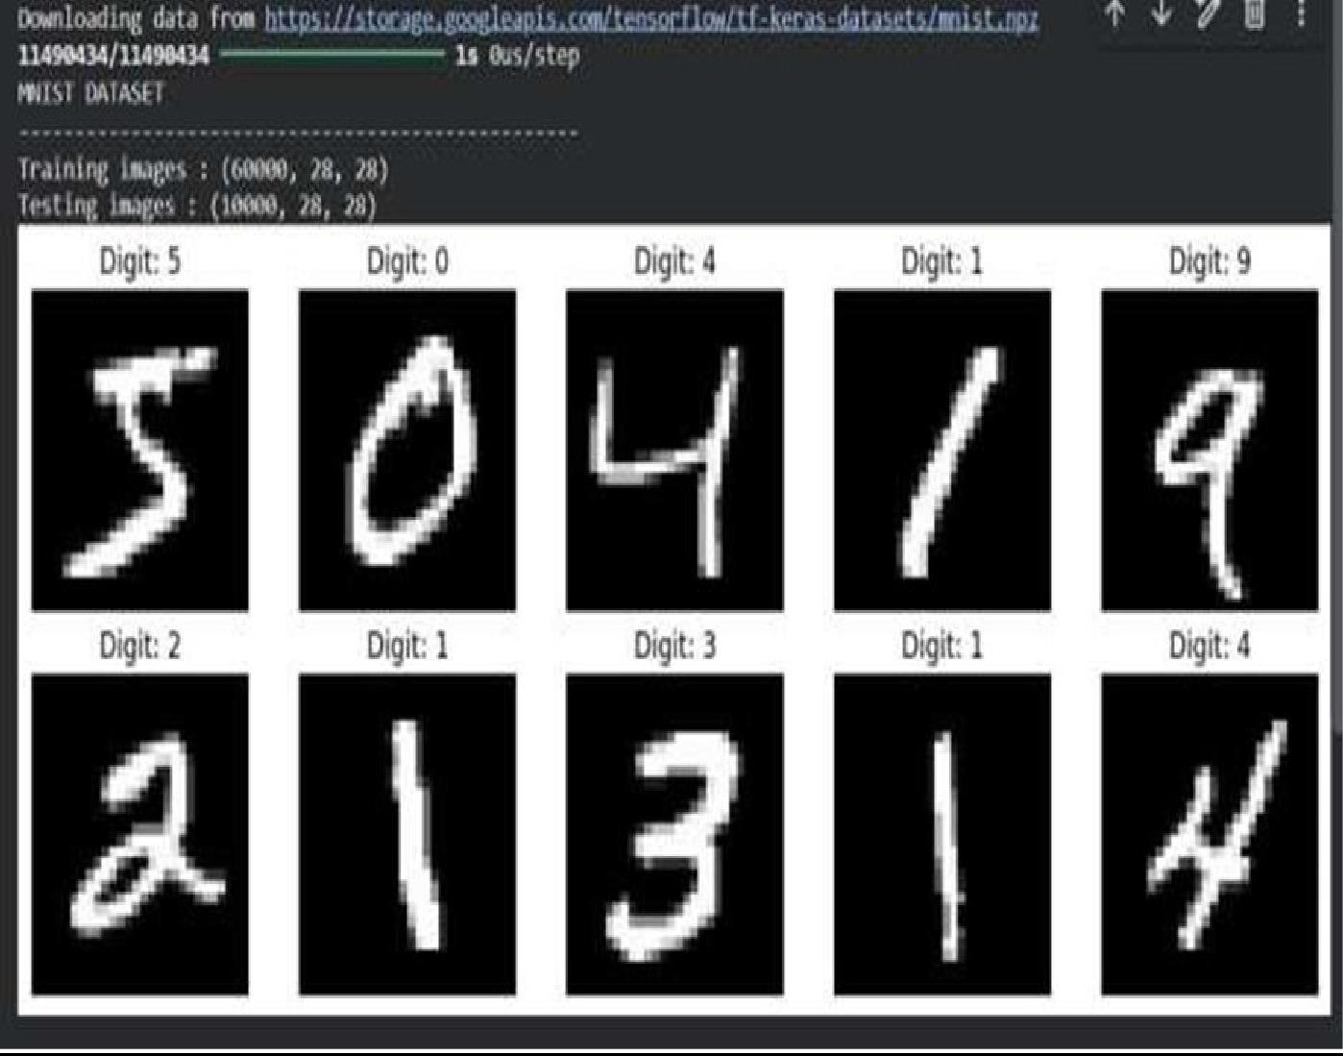

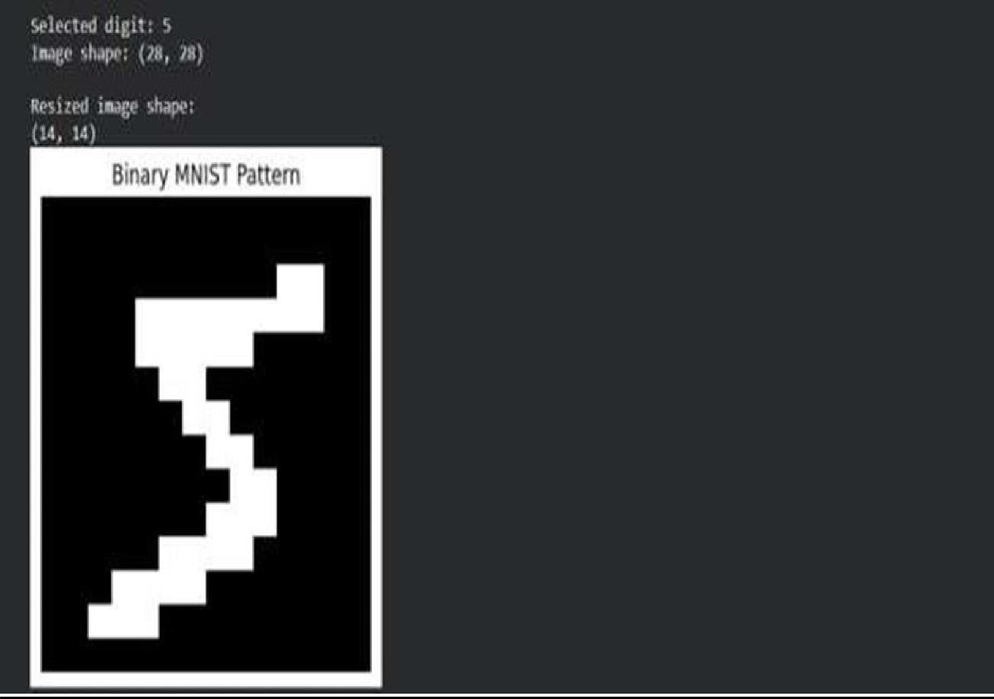
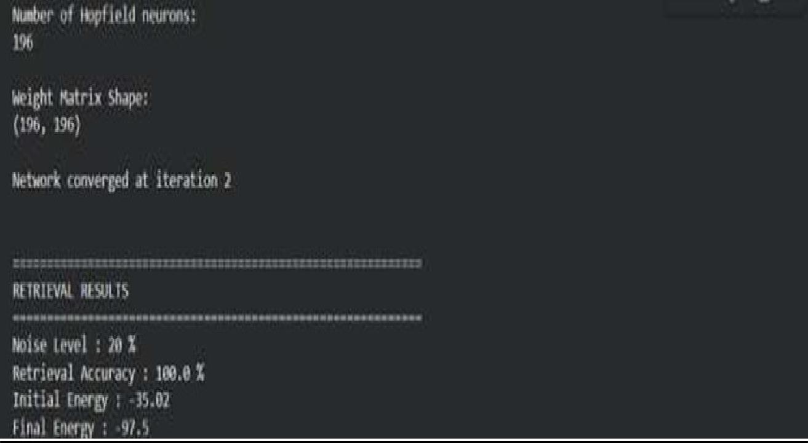

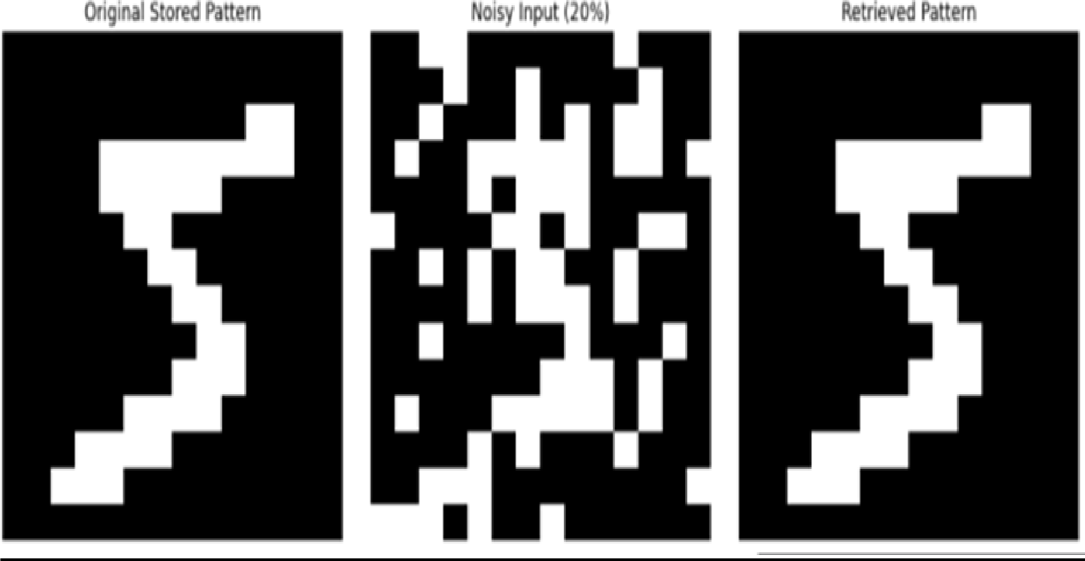

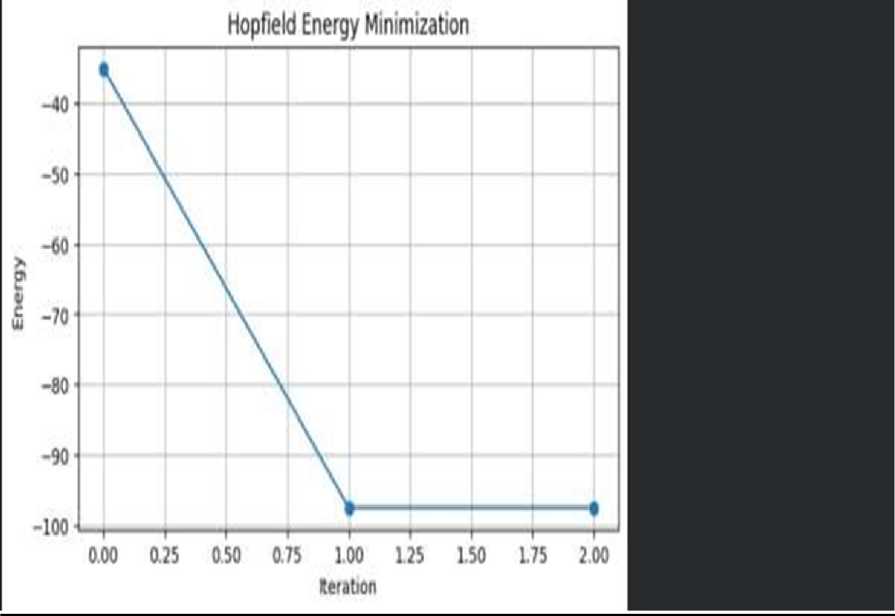

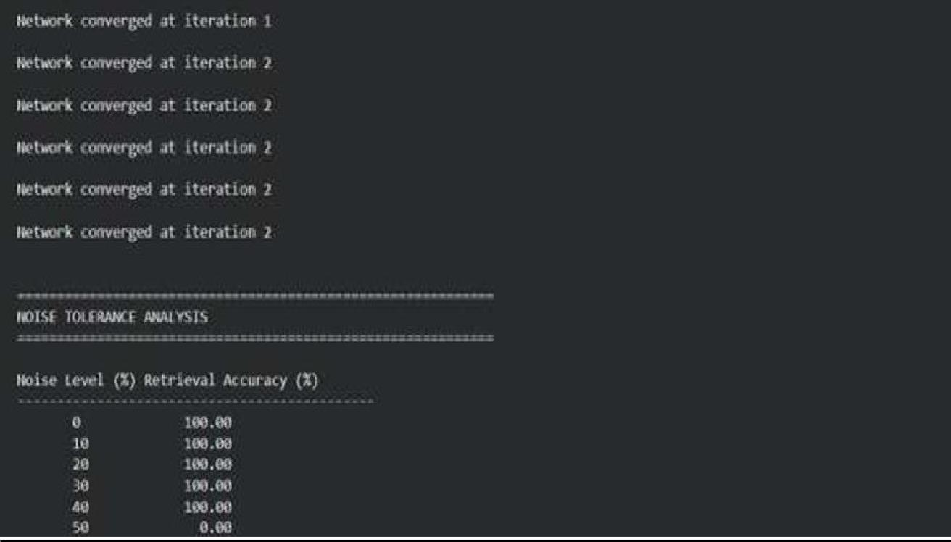

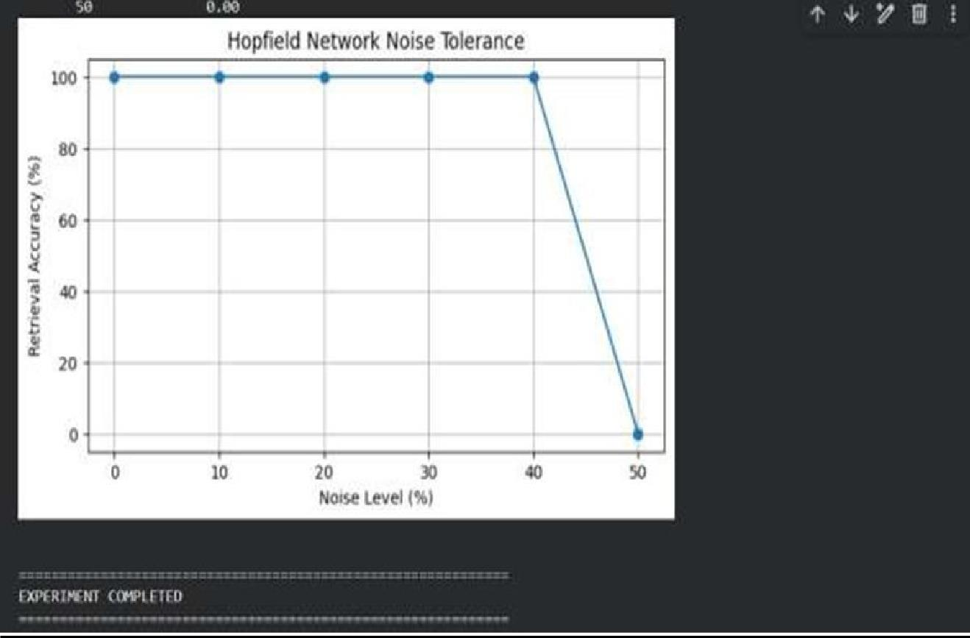

PRACTICAL :- 7

Practical-7
Aim :-Fuzzy Logic Based Air Conditioner Control System

Problem Statement-1
Design a Fuzzy Inference System that controls air conditioner fan speed based on room temperature and humidity.
Source Code:-

# Fuzzy Logic Based Air Conditioner Control System # Step 1: Install required library
!pip install scikit-fuzzy -q
# Step 2: Import required libraries import numpy as np
import skfuzzy as fuzz
from skfuzzy import control as ctrl import matplotlib.pyplot as plt
# Step 3: Define Input and Output Variables # Temperature: 0 to 50 degree Celsius
temperature = ctrl.Antecedent(np.arange(0, 51, 1), 'temperature')
# Humidity: 0 to 100 percent
humidity = ctrl.Antecedent(np.arange(0, 101, 1), 'humidity') # Fan Speed: 0 to 100 percent
fan_speed = ctrl.Consequent(np.arange(0, 101, 1), 'fan_speed')

# Step 4: Define Membership Functions
# ---------- Temperature Membership Functions ----------temperature['cold'] = fuzz.trimf(
temperature.universe, [0, 0, 20]
)

temperature['comfortable'] = fuzz.trimf( temperature.universe, [15, 25, 35]
)

temperature['hot'] = fuzz.trimf( temperature.universe, [30, 50, 50]
)

# ---------- Humidity Membership Functions ----------humidity['dry'] = fuzz.trimf(
humidity.universe, [0, 0, 40]
)

humidity['normal'] = fuzz.trimf( humidity.universe, [30, 50, 70]
)

humidity['humid'] = fuzz.trimf( humidity.universe, [60, 100, 100]
)

# ---------- Fan Speed Membership Functions ----------fan_speed['low'] = fuzz.trimf(

fan_speed.universe, [0, 0, 40]
)

fan_speed['medium'] = fuzz.trimf( fan_speed.universe, [30, 50, 70]
)

fan_speed['high'] = fuzz.trimf( fan_speed.universe, [60, 100, 100]
)
# Step 5: Display Membership Functions temperature.view()
plt.title("Temperature Membership Functions") plt.show()

humidity.view()
plt.title("Humidity Membership Functions") plt.show()
fan_speed.view()
plt.title("Fan Speed Membership Functions") plt.show()
# Step 6: Define Fuzzy Rules
# Rule 1: Cold + Dry -> Low Fan Speed

rule1 = ctrl.Rule( temperature['cold'] & humidity['dry'],

fan_speed['low']
)

# Rule 2: Cold + Normal -> Low Fan Speed rule2 = ctrl.Rule(
temperature['cold'] & humidity['normal'], fan_speed['low']
)

# Rule 3: Cold + Humid -> Medium Fan Speed rule3 = ctrl.Rule(
temperature['cold'] & humidity['humid'], fan_speed['medium']
)

# Rule 4: Comfortable + Dry -> Medium Fan Speed rule4 = ctrl.Rule(

temperature['comfortable'] & humidity['dry'], fan_speed['medium']
)
# Rule 5: Comfortable + Normal -> Medium Fan Speed rule5 = ctrl.Rule(
temperature['comfortable'] & humidity['normal'], fan_speed['medium']
)

# Rule 6: Comfortable + Humid -> High Fan Speed rule6 = ctrl.Rule(
temperature['comfortable'] & humidity['humid'], fan_speed['high']
)
# Rule 7: Hot + Dry -> High Fan Speed rule7 = ctrl.Rule( temperature['hot'] & humidity['dry'], fan_speed['high']
)
# Rule 8: Hot + Normal -> High Fan Speed rule8 = ctrl.Rule(
temperature['hot'] & humidity['normal'], fan_speed['high']
)
# Rule 9: Hot + Humid -> High Fan Speed

rule9 = ctrl.Rule(
temperature['hot'] & humidity['humid'], fan_speed['high']
)
# Step 7: Create Fuzzy Control System fan_control = ctrl.ControlSystem([ rule1, rule2, rule3,
rule4, rule5, rule6, rule7, rule8, rule9
])

fan_simulation = ctrl.ControlSystemSimulation(fan_control) # Step 8: Take Input from User
temp_input = float(input("Enter room temperature (°C): ")) humidity_input = float(input("Enter room humidity (%): "))

# Step 9: Validate Input
if not (0 <= temp_input <= 50):

raise ValueError("Temperature must be between 0 and 50 °C.")

if not (0 <= humidity_input <= 100):
raise ValueError("Humidity must be between 0 and 100 %.") # Step 10: Pass Inputs to Fuzzy System
fan_simulation.input['temperature'] = temp_input fan_simulation.input['humidity'] = humidity_input

# Step 11: Perform Fuzzy Inference and Defuzzification fan_simulation.compute()
output_speed = fan_simulation.output['fan_speed']

# Step 12: Display Result print("\n==========================================")

print(" AIR CONDITIONER CONTROL SYSTEM") print("==========================================")
print(f"Room Temperature : {temp_input:.2f} °C") print(f"Room Humidity : {humidity_input:.2f} %") print(f"Fan Speed : {output_speed:.2f} %") print("==========================================")

# Step 13: Classify Fan Speed

if output_speed < 40: speed_category = "LOW"
elif output_speed < 70: speed_category = "MEDIUM"
else:
speed_category = "HIGH"

print(f"Fan Speed Level : {speed_category}")

# Step 14: Display Defuzzification Result

fan_speed.view(sim=fan_simulation) plt.title("Defuzzified Fan Speed") plt.show()

OUTPUT:-

━━━━━━━━━━━━━━━━━━━━━━━━━━━━━━━━━━━━━━━━

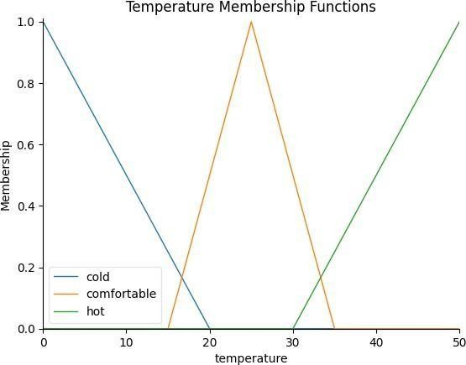

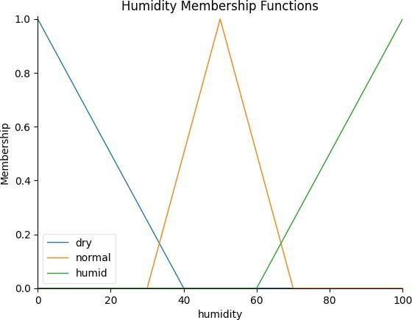
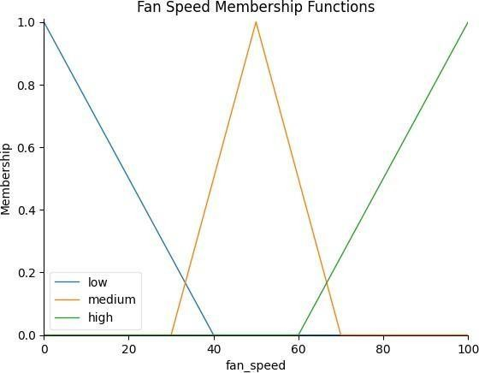

Enter room temperature (°C): 35 Enter room humidity (%): 74

========================================== AIR CONDITIONER CONTROL SYSTEM
==========================================
Room Temperature : 35.00 °C Room Humidity : 74.00 % Fan Speed : 82.38 %
==========================================
Fan Speed Level : HIGH

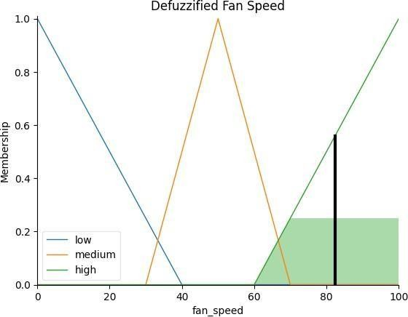

PRACTICAL :- 8
Practical 08
Aim:- Fuzzy Expert System for Medical Diagnosis
Problem Statement-1
Develop a fuzzy expert system to estimate the risk level of diabetes based on blood sugar level, BMI and age.
Objectives
- Apply fuzzy reasoning.
- Create rule base.
- Compare crisp and fuzzy decisions.

Source Code:-

# ============================================================ # FUZZY EXPERT SYSTEM FOR MEDICAL DIAGNOSIS
# Diabetes Risk Estimation using Blood Sugar, BMI and Age
# ============================================================

# ============================================================
# Step 1: Install Required Library
# ============================================================

!pip install scikit-fuzzy -q

# ============================================================
# Step 2: Import Required Libraries
# ============================================================

import numpy as np import skfuzzy as fuzz
from skfuzzy import control as ctrl import matplotlib.pyplot as plt

# ============================================================
# Step 3: Define Input and Output Variables
# ============================================================

# Blood Sugar: 50 to 300 mg/dL

blood_sugar = ctrl.Antecedent( np.arange(50, 301, 1), 'blood_sugar'
)

# BMI: 10 to 50
bmi = ctrl.Antecedent( np.arange(10, 51, 1), 'bmi'
)

# Age: 10 to 100 years age = ctrl.Antecedent(
np.arange(10, 101, 1), 'age'
)

# Diabetes Risk: 0 to 100 % diabetes_risk = ctrl.Consequent(
np.arange(0, 101, 1), 'diabetes_risk'
)

# ============================================================
# Step 4: Define Membership Functions
# ============================================================

#
# Blood Sugar Membership Functions #

blood_sugar['low'] = fuzz.trimf( blood_sugar.universe,
[50, 50, 100]
)

blood_sugar['normal'] = fuzz.trimf( blood_sugar.universe,
[80, 100, 125]
)

blood_sugar['high'] = fuzz.trimf( blood_sugar.universe,

[110, 160, 220]
)

blood_sugar['very_high'] = fuzz.trimf( blood_sugar.universe,
[180, 300, 300]
)

#
# BMI Membership Functions #

bmi['underweight'] = fuzz.trimf( bmi.universe,
[10, 10, 18.5]
)

bmi['normal'] = fuzz.trimf( bmi.universe,
[17, 22, 25]
)

bmi['overweight'] = fuzz.trimf( bmi.universe,
[23, 27, 30]
)

bmi['obese'] = fuzz.trimf( bmi.universe,
[28, 40, 50]
)

#
# Age Membership Functions #

age['young'] = fuzz.trimf(

age.universe, [10, 10, 30]
)

age['middle'] = fuzz.trimf( age.universe,
[25, 45, 60]
)

age['old'] = fuzz.trimf( age.universe,
[50, 75, 100]
)

#
# Diabetes Risk Membership Functions #

diabetes_risk['low'] = fuzz.trimf( diabetes_risk.universe,
[0, 0, 40]
)

diabetes_risk['medium'] = fuzz.trimf( diabetes_risk.universe,
[30, 50, 70]
)

diabetes_risk['high'] = fuzz.trimf( diabetes_risk.universe,
[60, 100, 100]
)

# ============================================================
# Step 5: Display Membership Functions
# ============================================================

blood_sugar.view()
plt.title("Blood Sugar Membership Functions") plt.show()

bmi.view()
plt.title("BMI Membership Functions") plt.show()

age.view()
plt.title("Age Membership Functions") plt.show()
diabetes_risk.view()
plt.title("Diabetes Risk Membership Functions") plt.show()

# ============================================================
# Step 6: Define Fuzzy Rules
# ============================================================

rules = []

# ============================================================ # BLOOD SUGAR = LOW
# ============================================================

rules.append(ctrl.Rule( blood_sugar['low'] & bmi['underweight'] & age['young'], diabetes_risk['low']
))

rules.append(ctrl.Rule( blood_sugar['low'] & bmi['underweight'] & age['middle'], diabetes_risk['low']
))

rules.append(ctrl.Rule( blood_sugar['low'] & bmi['underweight'] & age['old'], diabetes_risk['low']
))

rules.append(ctrl.Rule( blood_sugar['low'] & bmi['normal'] & age['young'], diabetes_risk['low']
))

rules.append(ctrl.Rule( blood_sugar['low'] & bmi['normal'] & age['middle'], diabetes_risk['low']
))

rules.append(ctrl.Rule( blood_sugar['low'] & bmi['normal'] & age['old'], diabetes_risk['medium']
))

rules.append(ctrl.Rule( blood_sugar['low'] & bmi['overweight'] & age['young'], diabetes_risk['medium']
))

rules.append(ctrl.Rule( blood_sugar['low'] & bmi['overweight'] & age['middle'], diabetes_risk['medium']
))

rules.append(ctrl.Rule( blood_sugar['low'] & bmi['overweight'] & age['old'], diabetes_risk['medium']
))

rules.append(ctrl.Rule(

blood_sugar['low'] & bmi['obese'] &
age['young'], diabetes_risk['medium']
))
rules.append(ctrl.Rule( blood_sugar['low'] & bmi['obese'] &
age['middle'], diabetes_risk['medium']
))

rules.append(ctrl.Rule( blood_sugar['low'] & bmi['obese'] &
age['old'], diabetes_risk['high']
))

# ============================================================ # BLOOD SUGAR = NORMAL
# ============================================================

rules.append(ctrl.Rule( blood_sugar['normal'] & bmi['underweight'] & age['young'], diabetes_risk['low']
))

rules.append(ctrl.Rule( blood_sugar['normal'] & bmi['underweight'] & age['middle'], diabetes_risk['low']
))

rules.append(ctrl.Rule( blood_sugar['normal'] & bmi['underweight'] & age['old'], diabetes_risk['medium']
))

rules.append(ctrl.Rule( blood_sugar['normal'] &
bmi['normal'] & age['young'], diabetes_risk['low']
))

rules.append(ctrl.Rule( blood_sugar['normal'] & bmi['normal'] & age['middle'], diabetes_risk['low']
))

rules.append(ctrl.Rule( blood_sugar['normal'] & bmi['normal'] & age['old'], diabetes_risk['medium']
))

rules.append(ctrl.Rule( blood_sugar['normal'] & bmi['overweight'] & age['young'], diabetes_risk['medium']
))

rules.append(ctrl.Rule( blood_sugar['normal'] & bmi['overweight'] & age['middle'], diabetes_risk['medium']
))

rules.append(ctrl.Rule( blood_sugar['normal'] & bmi['overweight'] & age['old'], diabetes_risk['high']
))

rules.append(ctrl.Rule(

blood_sugar['normal'] & bmi['obese'] &
age['young'], diabetes_risk['medium']
))

rules.append(ctrl.Rule( blood_sugar['normal'] & bmi['obese'] &
age['middle'], diabetes_risk['high']
))

rules.append(ctrl.Rule( blood_sugar['normal'] & bmi['obese'] &
age['old'], diabetes_risk['high']
))

# ============================================================ # BLOOD SUGAR = HIGH
# ============================================================

rules.append(ctrl.Rule( blood_sugar['high'] & bmi['underweight'] & age['young'], diabetes_risk['medium']
))

rules.append(ctrl.Rule( blood_sugar['high'] & bmi['underweight'] & age['middle'], diabetes_risk['high']
))

rules.append(ctrl.Rule( blood_sugar['high'] & bmi['underweight'] & age['old'],

diabetes_risk['high']
))
rules.append(ctrl.Rule( blood_sugar['high'] & bmi['normal'] & age['young'], diabetes_risk['medium']
))

rules.append(ctrl.Rule( blood_sugar['high'] & bmi['normal'] & age['middle'], diabetes_risk['high']
))

rules.append(ctrl.Rule( blood_sugar['high'] & bmi['normal'] & age['old'], diabetes_risk['high']
))

rules.append(ctrl.Rule( blood_sugar['high'] & bmi['overweight'] & age['young'], diabetes_risk['high']
))

rules.append(ctrl.Rule( blood_sugar['high'] & bmi['overweight'] & age['middle'], diabetes_risk['high']
))

rules.append(ctrl.Rule( blood_sugar['high'] & bmi['overweight'] & age['old'], diabetes_risk['high']
))
rules.append(ctrl.Rule(

blood_sugar['high'] & bmi['obese'] &
age['young'], diabetes_risk['high']
))

rules.append(ctrl.Rule( blood_sugar['high'] & bmi['obese'] &
age['middle'], diabetes_risk['high']
))

rules.append(ctrl.Rule( blood_sugar['high'] & bmi['obese'] &
age['old'], diabetes_risk['high']
))

# ============================================================ # BLOOD SUGAR = VERY HIGH
# ============================================================

rules.append(ctrl.Rule( blood_sugar['very_high'] & bmi['underweight'] & age['young'], diabetes_risk['high']
))

rules.append(ctrl.Rule( blood_sugar['very_high'] & bmi['underweight'] & age['middle'], diabetes_risk['high']
))

rules.append(ctrl.Rule( blood_sugar['very_high'] & bmi['underweight'] &

age['old'], diabetes_risk['high']
))

rules.append(ctrl.Rule( blood_sugar['very_high'] & bmi['normal'] & age['young'], diabetes_risk['high']
))

rules.append(ctrl.Rule( blood_sugar['very_high'] & bmi['normal'] & age['middle'], diabetes_risk['high']
))

rules.append(ctrl.Rule( blood_sugar['very_high'] & bmi['normal'] & age['old'], diabetes_risk['high']
))

rules.append(ctrl.Rule( blood_sugar['very_high'] & bmi['overweight'] & age['young'], diabetes_risk['high']
))

rules.append(ctrl.Rule( blood_sugar['very_high'] & bmi['overweight'] & age['middle'], diabetes_risk['high']
))

rules.append(ctrl.Rule( blood_sugar['very_high'] & bmi['overweight'] & age['old'],

diabetes_risk['high']
))

rules.append(ctrl.Rule( blood_sugar['very_high'] & bmi['obese'] &
age['young'], diabetes_risk['high']
))

rules.append(ctrl.Rule( blood_sugar['very_high'] & bmi['obese'] &
age['middle'], diabetes_risk['high']
))

rules.append(ctrl.Rule( blood_sugar['very_high'] & bmi['obese'] &
age['old'], diabetes_risk['high']
))

# ============================================================
# Step 7: Create Fuzzy Control System
# ============================================================
diabetes_control = ctrl.ControlSystem(rules) diabetes_simulation = ctrl.ControlSystemSimulation(
diabetes_control
)

# ============================================================
# Step 8: Take Input from User
# ============================================================

blood_sugar_input = float(
input("Enter blood sugar level (mg/dL): ")
)

bmi_input = float( input("Enter BMI: ")
)

age_input = float(
input("Enter age (years): ")
)

# ============================================================
# Step 9: Validate Input
# ============================================================

if not (50 <= blood_sugar_input <= 300): raise ValueError(
"Blood sugar must be between 50 and 300 mg/dL."
)

if not (10 <= bmi_input <= 50): raise ValueError(
"BMI must be between 10 and 50."
)

if not (10 <= age_input <= 100): raise ValueError(
"Age must be between 10 and 100 years."
)

# ============================================================
# Step 10: Pass Inputs to Fuzzy System
# ============================================================

diabetes_simulation.input['blood_sugar'] = blood_sugar_input diabetes_simulation.input['bmi'] = bmi_input diabetes_simulation.input['age'] = age_input

# ============================================================
# Step 11: Perform Fuzzy Inference and Defuzzification
# ============================================================

diabetes_simulation.compute()

output_risk = diabetes_simulation.output['diabetes_risk']

# ============================================================
# Step 12: Display Fuzzy Result
# ============================================================

print("\n==============================================") print(" FUZZY DIABETES RISK SYSTEM") print("==============================================")

print(
f"Blood Sugar : {blood_sugar_input:.2f} mg/dL"
)

print(
f"BMI : {bmi_input:.2f}"
)

print(
f"Age : {age_input:.2f} years"
)

print(
f"Fuzzy Risk Score : {output_risk:.2f} %"
) print("==============================================")

# ============================================================
# Step 13: Classify Fuzzy Risk
# ============================================================

if output_risk < 40: fuzzy_category = "LOW"

elif output_risk < 70: fuzzy_category = "MEDIUM"

else:

fuzzy_category = "HIGH"

print(
f"Fuzzy Risk Level : {fuzzy_category}"
)

# ============================================================
# Step 14: Crisp Decision
# ============================================================

# Simple threshold-based decision for comparison.
# This is an academic comparison and is not a clinical # diagnostic method.

if blood_sugar_input < 100: crisp_category = "LOW"

elif blood_sugar_input < 126: crisp_category = "MEDIUM"

else:
crisp_category = "HIGH"

# ============================================================
# Step 15: Display Crisp vs Fuzzy Decision
# ============================================================

print("\n==============================================") print(" CRISP VS FUZZY DECISION") print("==============================================")

print(
f"Crisp Decision : {crisp_category}"
)

print(
f"Fuzzy Decision : {fuzzy_category}"
)

print(

f"Fuzzy Risk Score : {output_risk:.2f} %"
)

print("==============================================")

# ============================================================
# Step 16: Compare the Results
# ============================================================
if crisp_category == fuzzy_category: print(
"Result: Crisp and Fuzzy decisions are SAME."
)

else:

print(
"Result: Crisp and Fuzzy decisions are DIFFERENT."
)

print(
"Fuzzy logic considers Blood Sugar, BMI and Age " "together using gradual membership values."
)

# ============================================================
# Step 17: Display Defuzzification Result
# ============================================================

diabetes_risk.view( sim=diabetes_simulation
)

plt.title("Defuzzified Diabetes Risk") plt.show()

OUTPUT:-
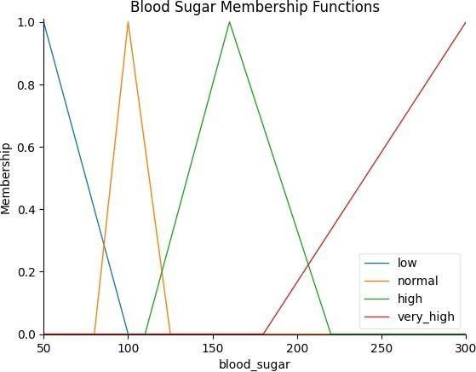
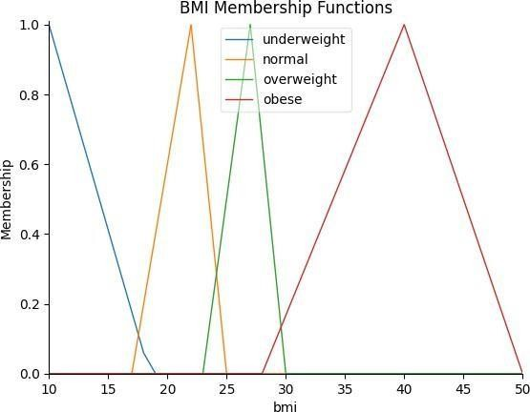

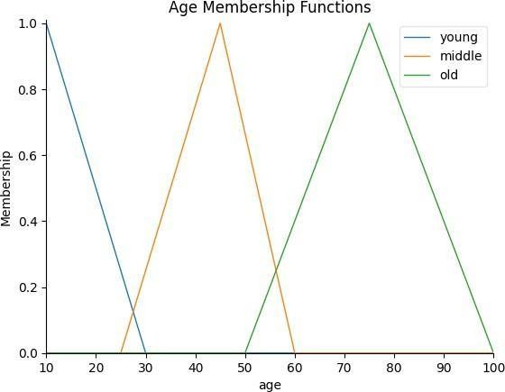
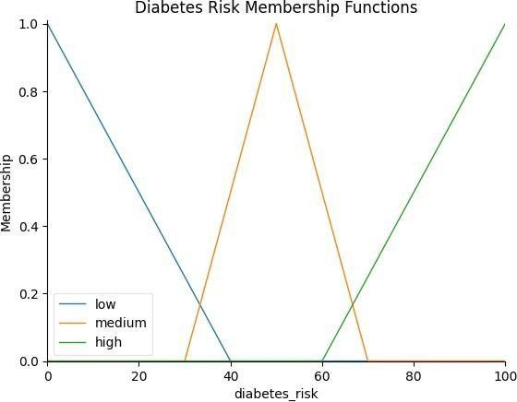

Enter blood sugar level (mg/dL): 96 Enter BMI: 35
Enter age (years): 20

============================================== FUZZY DIABETES RISK SYSTEM
==============================================
Blood Sugar : 96.00 mg/dL BMI : 35.00
Age : 20.00 years Fuzzy Risk Score : 50.00 %
==============================================
Fuzzy Risk Level : MEDIUM

============================================== CRISP VS FUZZY DECISION
==============================================
Crisp Decision : LOW Fuzzy Decision : MEDIUM Fuzzy Risk Score : 50.00 %
==============================================
Result: Crisp and Fuzzy decisions are DIFFERENT.
Fuzzy logic considers Blood Sugar, BMI and Age together using gradual membership values.

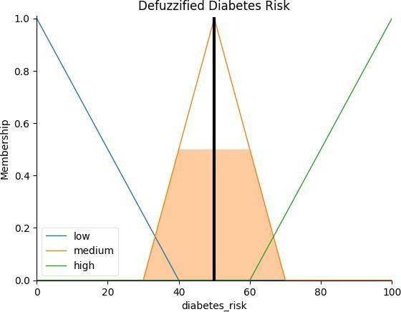

PRACTICAL :- 9

Practical-9

Problem Statement
Develop a soft computing model that classifies waste into Dry or Wet categories using measurable features such as moisture level, weight, and texture score. The experiment combines a data-driven Neural Network with a rule-
based Fuzzy Logic system and evaluates the performance of the resulting hybrid intelligent system.

import numpy as np import pandas as pd
import matplotlib.pyplot as plt

from sklearn.model_selection import train_test_split from sklearn.preprocessing import StandardScaler from sklearn.neural_network import MLPClassifier
from sklearn.metrics import accuracy_score, classification_report, confusion_matrix

#
# 1. Sample labeled dataset #

data = {
"Moisture": [
10, 15, 20, 25, 30, 35, 40, 45, 50, 55, 60, 65, 70, 75, 80, 85,
90,
12, 18, 28, 33, 42, 48, 58, 68, 78, 88, 22, 38, 72
],

550,

620,
"Weight": [
100, 150, 200, 120, 180, 220, 250, 300, 350, 400, 450, 500,

600, 650, 700, 750, 130, 170, 140, 230, 280, 320, 380, 520,

720, 190, 260, 580

],

3.8,
"Texture": [
8.5, 9.0, 8.0, 7.5, 8.2, 7.0, 6.8, 6.0, 5.5, 5.0, 4.5, 4.0,

3.5, 3.0, 2.5, 2.0, 9.2, 8.8, 8.0, 7.2, 6.5, 6.0, 5.2, 4.2,
3.5, 2.2, 8.3, 6.7, 3.8

],

# 0 = Dry, 1 = Wet "Label": [
 |  | 0, | 0, | 0, | 0, | 0, | 0, 0, 0, | 0, 0,
 |  | 1, | 1, | 1, | 1, | 1, | 1, 1,
 |  | 0, | 0, | 0, | 0, | 0, | 0,
 |  | 1, | 1, | 1, | 1,
 |  | 0, | 0, | 1
 | ]
}

df = pd.DataFrame(data)

#
# 2. Train/test split #

X = df[["Moisture", "Weight", "Texture"]] y = df["Label"]

X_train, X_test, y_train, y_test = train_test_split( X,
y, test_size=0.25, random_state=42, stratify=y
)

# Feature scaling
scaler = StandardScaler()

X_train_scaled = scaler.fit_transform(X_train) X_test_scaled = scaler.transform(X_test)

#
# 3. Neural Network #

model = MLPClassifier( hidden_layer_sizes=(10, 8), activation="relu", solver="adam", max_iter=2000, random_state=42
)
model.fit(X_train_scaled, y_train) nn_prediction = model.predict(X_test_scaled) # Probability of Wet class
nn_probability = model.predict_proba(X_test_scaled)[:, 1]

#
# 4. Fuzzy membership functions #

def moisture_membership(moisture):

if moisture <= 20: dry = 1.0
wet = 0.0

elif moisture < 60:
dry = (60 - moisture) / 40 wet = (moisture - 20) / 40

else:
dry = 0.0
wet = 1.0 return dry, wet

def texture_membership(texture):

if texture <= 3: rough = 1.0
dry_texture = 0.0 elif texture < 7:
rough = (7 - texture) / 4 dry_texture = (texture - 3) / 4

else:
rough = 0.0
dry_texture = 1.0 return rough, dry_texture

def fuzzy_classifier(moisture, weight, texture): dry_moisture, wet_moisture = moisture_membership(moisture) rough_texture, dry_texture = texture_membership(texture)
#
# Fuzzy Rules #

wet_rule_1 = wet_moisture
wet_rule_2 = min(wet_moisture, rough_texture)

dry_rule_1 = dry_moisture
dry_rule_2 = min(dry_moisture, dry_texture)

# Combine rules
wet_score = max(wet_rule_1, wet_rule_2) dry_score = max(dry_rule_1, dry_rule_2)

# Final fuzzy class
if wet_score > dry_score: fuzzy_class = 1
else:
fuzzy_class = 0

# Convert scores into probability total = wet_score + dry_score

if total != 0:
fuzzy_wet_probability = wet_score / total else:
fuzzy_wet_probability = 0.5
return fuzzy_wet_probability, fuzzy_class

#
# 5. Hybrid Model #

hybrid_predictions = []

for i in range(len(X_test)):

moisture = X_test.iloc[i]["Moisture"] weight = X_test.iloc[i]["Weight"] texture = X_test.iloc[i]["Texture"]

fuzzy_probability, _ = fuzzy_classifier( moisture,
weight, texture
)

# 60% Neural Network # 40% Fuzzy Logic

hybrid_probability = (
0.60 * nn_probability[i] +
0.40 * fuzzy_probability
)

final_prediction = 1 if hybrid_probability >= 0.50 else 0 hybrid_predictions.append(final_prediction)

#

# 6. Evaluation
#

accuracy = accuracy_score( y_test, hybrid_predictions
)
print("HYBRID MODEL ACCURACY:",
round(accuracy * 100, 2), "%")

print("\nCLASSIFICATION REPORT:")

print(
classification_report( y_test, hybrid_predictions,
target_names=["Dry", "Wet"]
)
)

cm = confusion_matrix( y_test, hybrid_predictions
)

print("\nCONFUSION MATRIX:")
print(cm)

#
# 7. Classify a new waste item #

new_moisture = 72
new_weight = 450
new_texture = 3.5

new_data = np.array([
[new_moisture, new_weight, new_texture]
])

# Scale new data
new_scaled = scaler.transform(new_data)

# Neural Network probability new_nn_probability = model.predict_proba(
new_scaled
)[0][1]

# Fuzzy probability
new_fuzzy_probability, _ = fuzzy_classifier( new_moisture,
new_weight, new_texture
)

# Hybrid probability new_hybrid_probability = (
0.60 * new_nn_probability +
0.40 * new_fuzzy_probability
)

# Final classification final_class = (
"Wet"
if new_hybrid_probability >= 0.50 else "Dry"
)

print("\nNEW WASTE")

print("Moisture:", new_moisture, "%") print("Weight:", new_weight, "g") print("Texture:", new_texture)

print(
"NN Wet Probability:", round(new_nn_probability, 3)
)

print(
"Fuzzy Wet Probability:",

round(new_fuzzy_probability, 3)
)

print(
"Hybrid Wet Probability:", round(new_hybrid_probability, 3)
)
print("FINAL CLASS:", final_class)

#
# 8. Confusion Matrix Plot #

plt.figure(figsize=(6, 5))

plt.imshow( cm,
cmap="Blues"
)

plt.title("Hybrid Model Confusion Matrix")

plt.xlabel("Predicted Class") plt.ylabel("Actual Class")

plt.xticks(
[0, 1],
["Dry", "Wet"]
)

plt.yticks(
[0, 1],
["Dry", "Wet"]
)

# Display values inside matrix for i in range(2):
for j in range(2): plt.text(
j,

i,
cm[i, j], ha="center", va="center"
)

plt.colorbar() plt.tight_layout()

plt.show()

OUTPUT:-
HYBRID MODEL ACCURACY: 100.0 %

CLASSIFICATION REPORT:
precision recall f1-score support

Dry | 1.00 | 1.00 | 1.00 | 5
Wet | 1.00 | 1.00 | 1.00 | 3

accuracy |  | 1.00 | 8
macro avg | 1.00 | 1.00 1.00 |  | 8
weighted avg | 1.00 | 1.00 1.00 |  | 8

CONFUSION MATRIX: [[5 0]
[0 3]]

NEW WASTE
Moisture: 72 %
Weight: 450 g
Texture: 3.5
NN Wet Probability: 0.973 Fuzzy Wet Probability: 1.0 Hybrid Wet Probability: 0.984 FINAL CLASS: Wet

